

Assessment Report

Student name: Mark Beresford

Student Number: 471731221

Unit/Cluster: ICTWEB519_520

Assessment Number: 3



Contents

Title 3

ML Strength – Health and Fitness 3

1. Project Requirements (Part 1) 3

Client Requirements 3

1.8 Wireframes 6

1.9 Styling Information 17

Typography 17

Iconography 17

Colour Scheme 18

2. Test, debug and validate (Part 3) 19

3.3 Validation 19

**3.3 HTML Validation Testing** 19

**3.3 CSS Validation Testing** 27

style.css Test -1 27

3.4 Browser/Device Testing 28

3.5 Autoprefixer 65

3.6 Accessibility Testing 69

3.7 Cyber security measures 74

Authentication process 74

Programmatically engineered solutions to avoid cyber-attacks 74

Internet protocols 74

Project Signoff 74

Appendices 74

References 74

Title

ML Strength – Health and Fitness

Date: 12/05/2023

1. Project Requirements (Part 1)

Client Requirements

* 1. What does the client want to achieve with this web page?

To entice health conscience adults who are looking for something slightly different from a local gym, that doesn’t come on strong with selling gimmicks, and is geared to putting the needs of the customer first.

* 1. Who is the target audience for the page?

Health conscience local adults, who need a gym to be able to fit in around their schedule, and that offer a wide range of classes. Specific areas on offer are weight-loss, boxing and karate.

* 1. Are there any legislative or organisational standards that the designer/developer must comply with in the development of the web page?

|  |  |  |  |
| --- | --- | --- | --- |
| LEGAL OBLIGATION | | ACTIONS REQUIRED | SOURCE |
| Privacy Act | | * Inform your customers of what measures you have in place to protect their personal details, such as names, addresses and credit card details. * Check your privacy policy is compliant with Australian privacy law and is easily accessible on your website. | <https://www.business.qld.gov.au/running-business/digital-business/online-risk-security/legal-obligations> |
| Legal Obligations and jurisdictions | * Assess your online business activities and the geographic areas your business operates within and identify the legal obligations that apply. * Create a plan to ensure that all your business activities comply. * Conduct regular reviews or sign up for updates to make you aware of any changes, or seek professional advice. | | <https://www.business.qld.gov.au/running-business/digital-business/online-risk-security/legal-obligations> |
| Email Marketing | * Comply with the [Spam Act 2003(Cwlth)](https://www.legislation.gov.au/Series/C2004A01214) | | <https://www.legislation.gov.au/Details/C2016C00614> |
| Copyright | * Images and content to meet copyright requirements * Have permissions to use intellectual property | |  |
| Consumer Law | * Online advertising is not false or misleading. * Online reviews are genuine. * Uphold responsibilities to customers. * Comply with Australian Product/Mandatory safety laws | | <https://www.business.qld.gov.au/running-business/digital-business/online-risk-security/legal-obligations> |
| Website term of use | * A terms of use document that includes information on protecting your business ideas, disclaimers and rules applying to anyone who interacts with your website. | | <https://www.business.qld.gov.au/running-business/digital-business/online-risk-security/legal-obligations> |
| Terms and Conditions | * If you sell products online, include terms and conditions outlining the operations of your business sales, payment options, cancellation policies, consumer guarantees, and return and refund policies. * You should also have a process for customer complaints. | | <https://www.business.qld.gov.au/running-business/digital-business/online-risk-security/legal-obligations> |
| Business Information | * Contact details are included and easy to find | | <https://www.business.qld.gov.au/running-business/digital-business/online-risk-security/legal-obligations> |
| Client Agreement | * If you provide services online, include a client agreement. * This should contain information about payment, expectations, termination of the agreement, and the process for handling disputes | | <https://www.business.qld.gov.au/running-business/digital-business/online-risk-security/legal-obligations> |
| Electronic Transactions | * Provide payment mechanisms that are easy to use and give appropriate security. * Clearly explain the security and authentication methods you use so customers can assess any risks | | <https://www.business.qld.gov.au/running-business/digital-business/online-risk-security/legal-obligations> |
| Accessibility Standards | * Comply with WCAG 2.0/2.1 standards * Ensure that WCAG 2.1 success criteria support mobile use-cases * Define a clear conformance model for WCAG 2.1/dot.x releases * Ensure the conformance structure utilizes the WCAG 2.0 A / AA / AAA model | | <https://www.w3.org/TR/WCAG20/>  <https://w3c.github.io/wcag21/requirements/> |

1.8 Wireframes

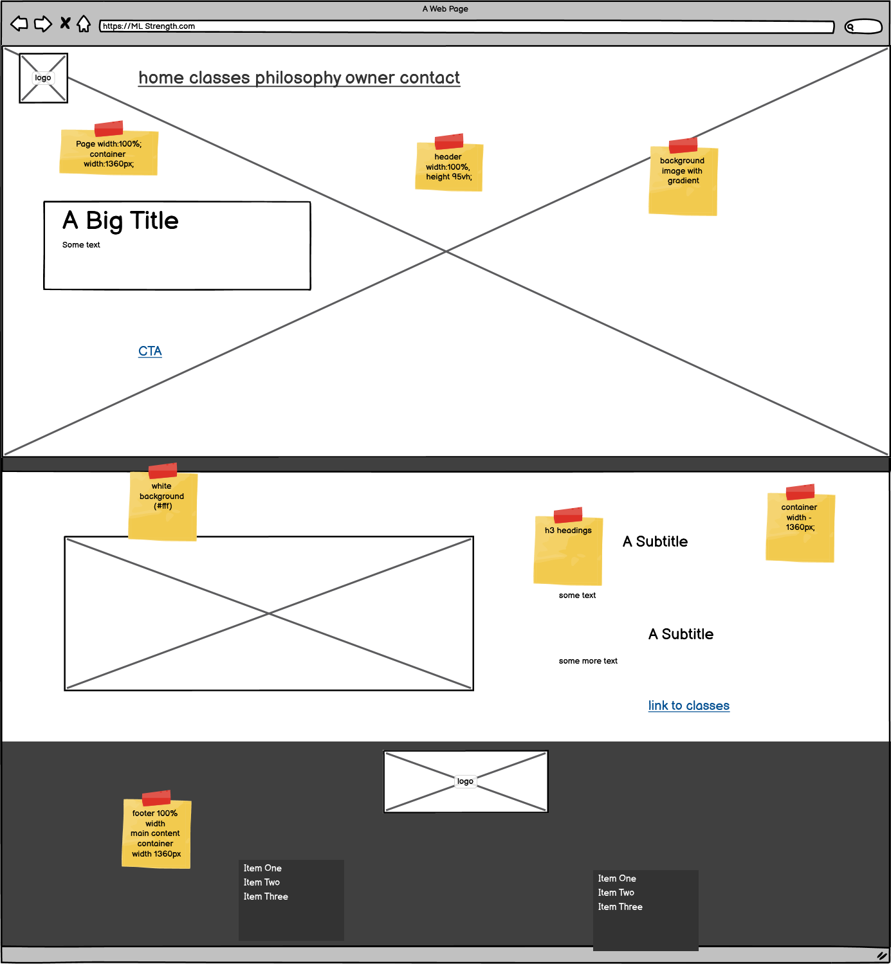

Desktop home-page

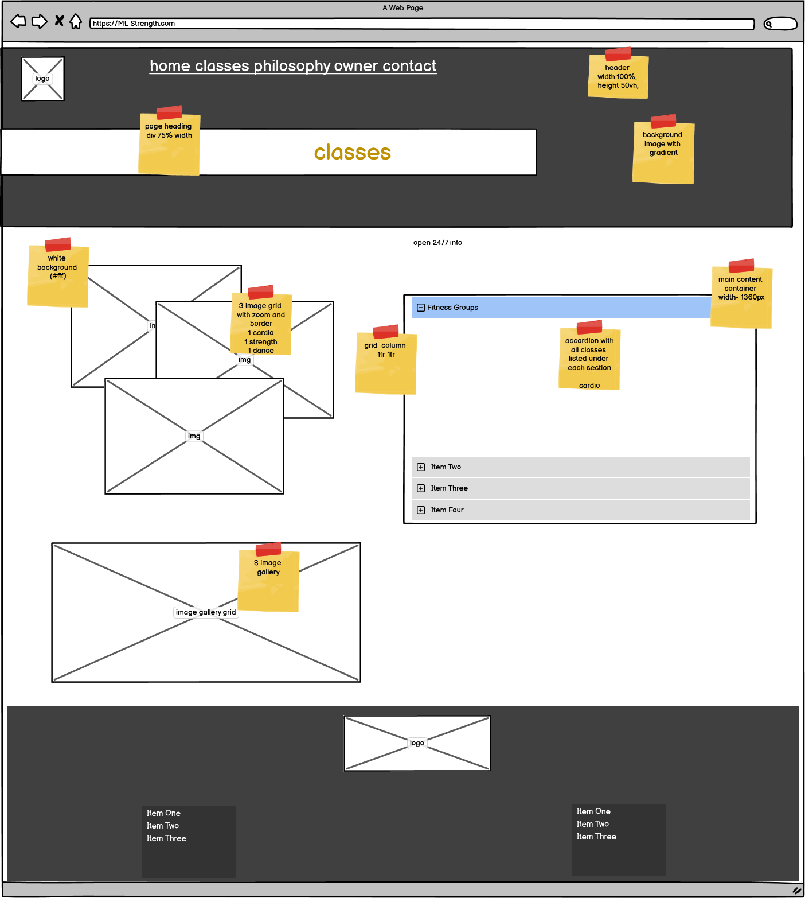

Desktop Classes page

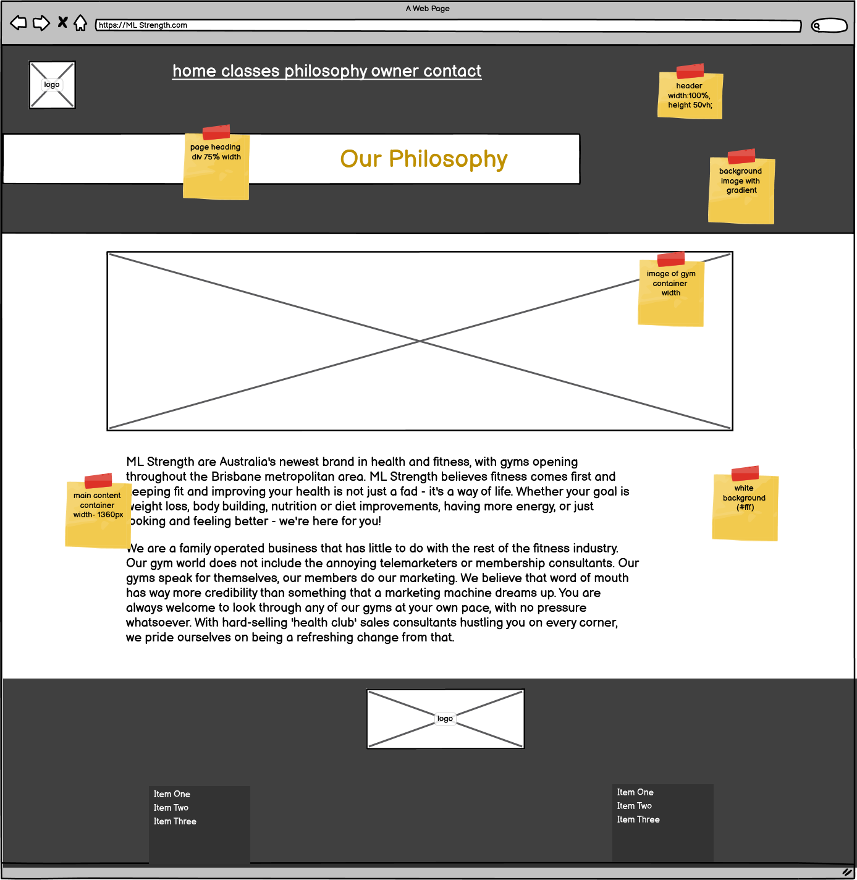

Desktop Philosophy page

Desktop Owner page

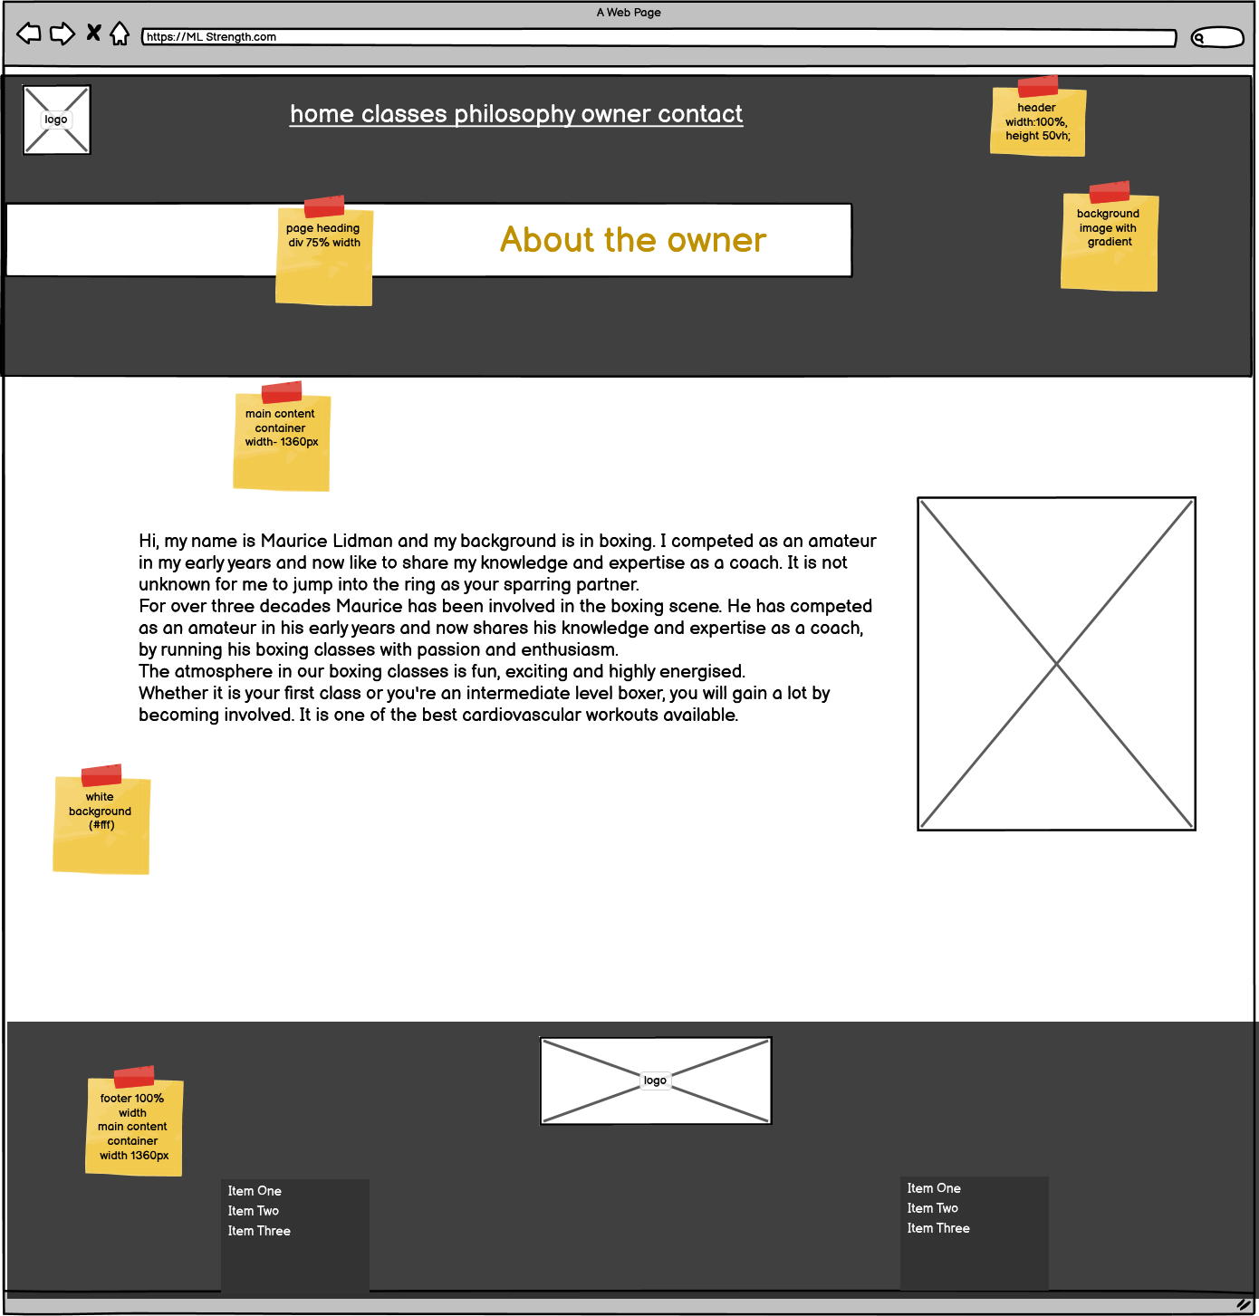

Desktop Contact form page

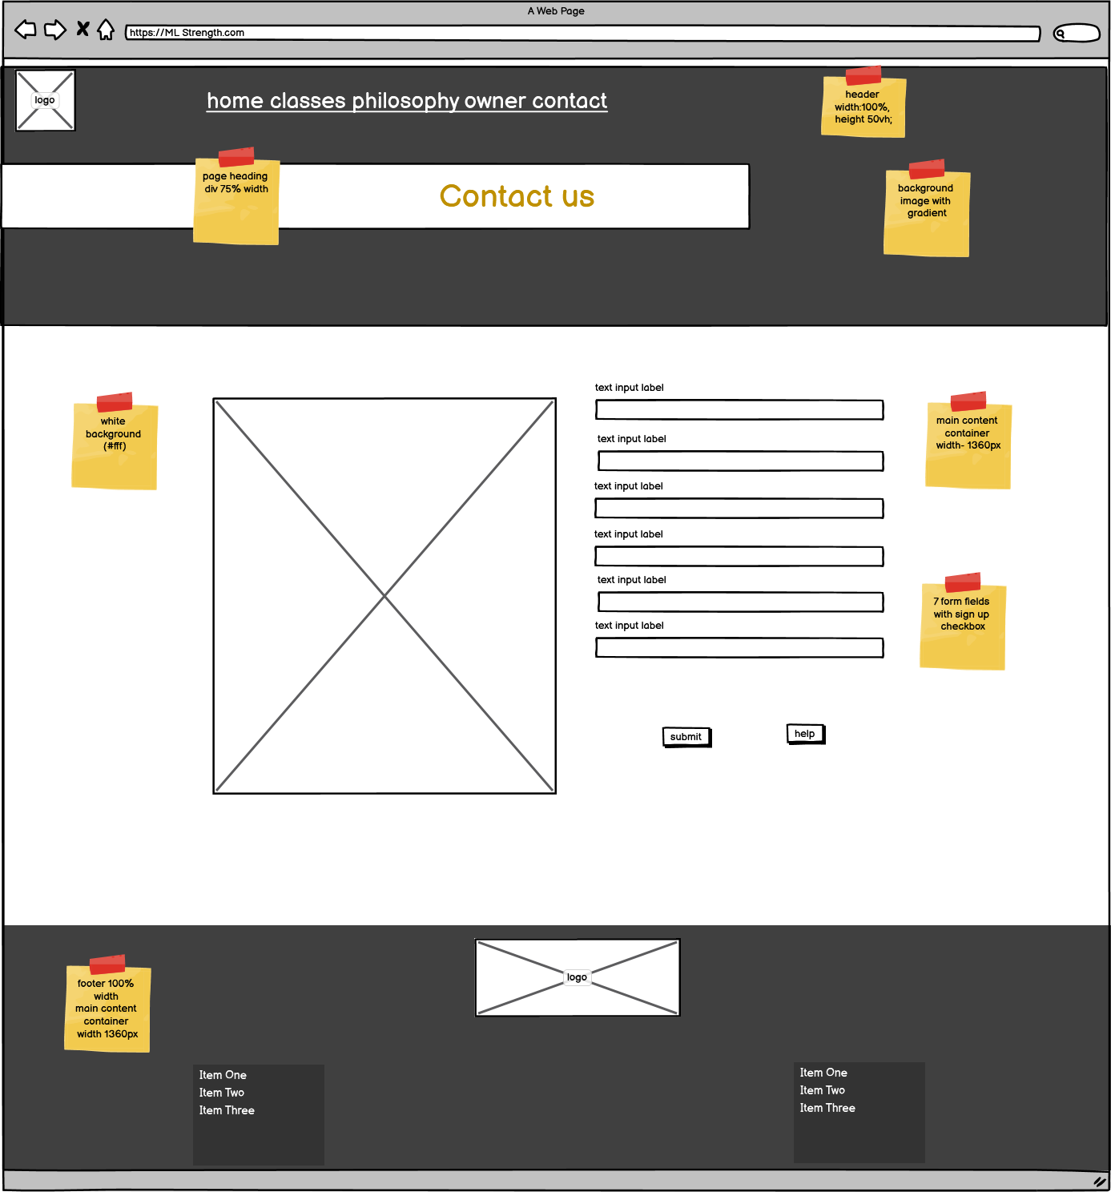

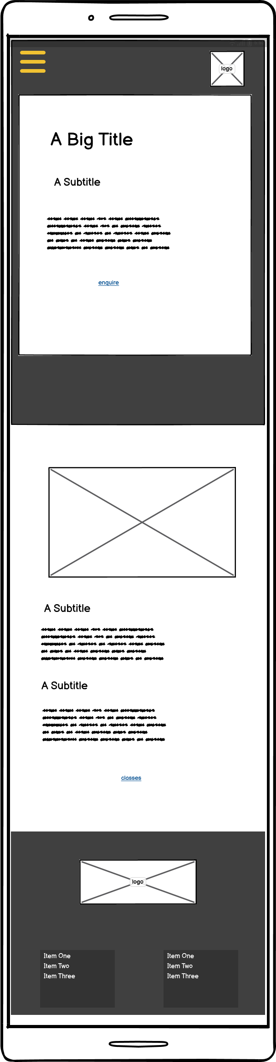

Mobile Index page

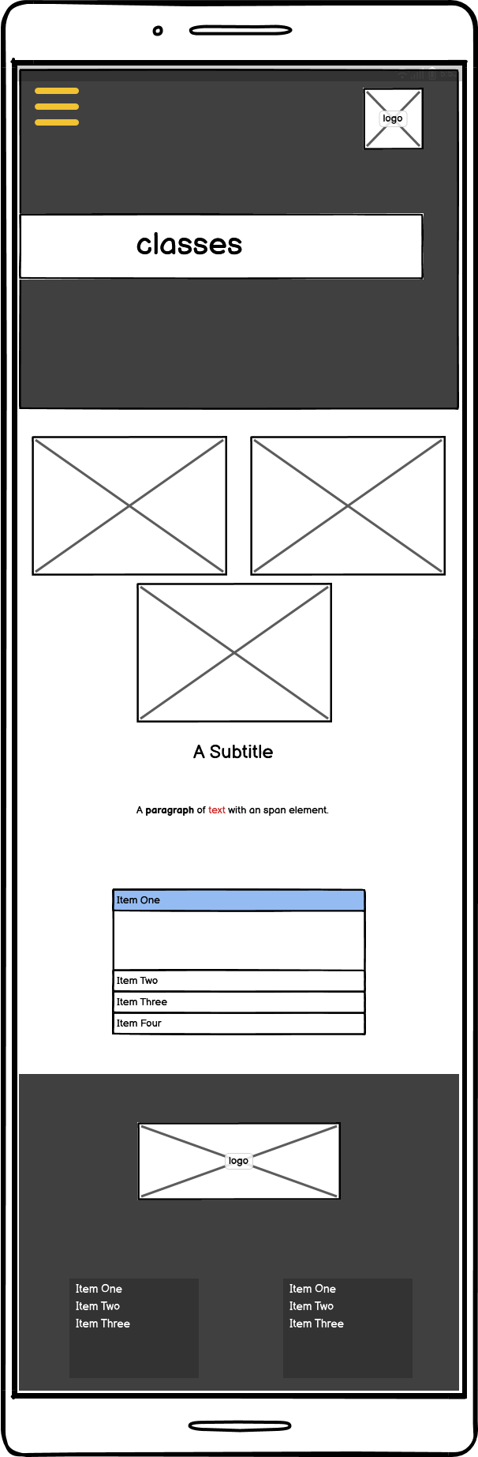

Mobile Classes page

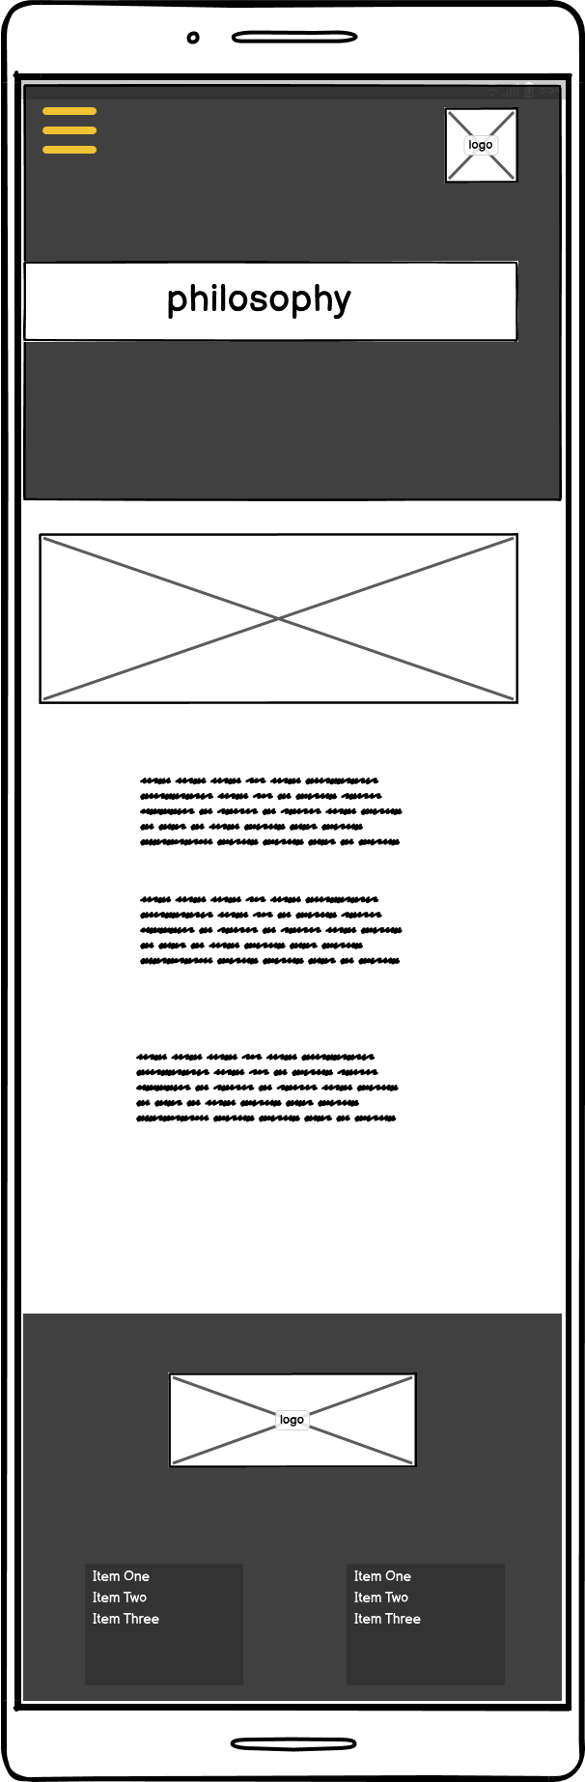

Mobile Philosophy page

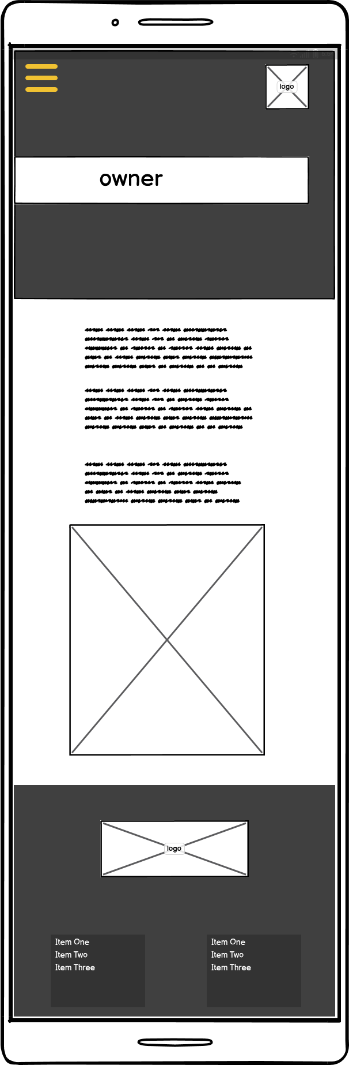

Mobile Owner page

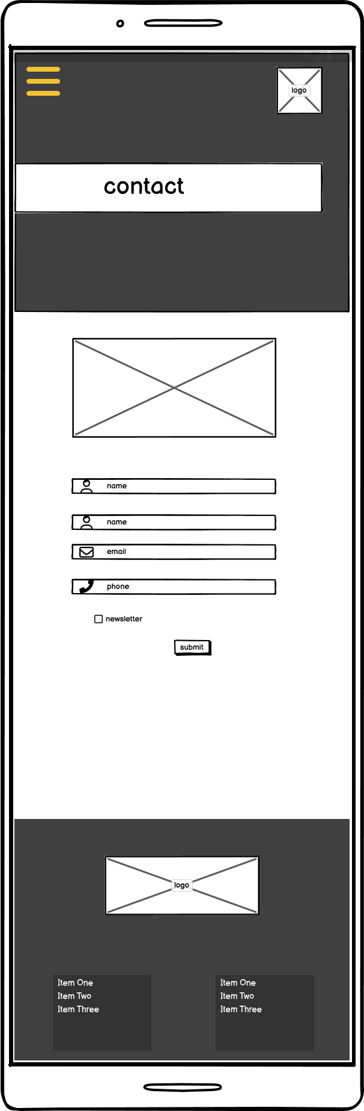

Mobile Contact page

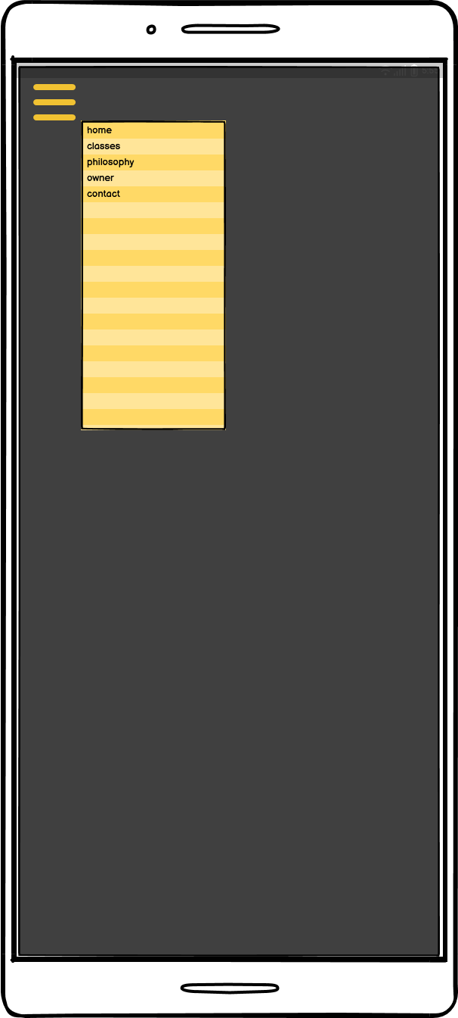

Pop-up Menu page

1.9 Styling Information

Typography

|  |  |
| --- | --- |
| Main Styles | |
| Title/Heading 1 | 60px - 40px |
| Heading 2 | 30px |
| Heading 3 | 25px - 30px |
| Heading 4 | 20px - 25px |
| Link: link, active and hover | 20px |
| Paragraph | 20px |
| Fig caption | 18px/14px/12px |
| Unordered Lists | 14px |
| Font-family | |
| Headings | Palanquin Dark |
| Paragraphs/list | Lato |
| Back-up | Sans serif |

Iconography

The iconography format style I chose is from the font-awesome, as they could be added using CSS content,. These can then be coloured using color in CSS, and sized using font-size in CSS.

Below is listed the specific icons I chose and why:

|  |  |
| --- | --- |
|  | To represent the name in the form field |
|  | To represent the email address in the form field |
|  | To represent the phone number in the form field |

Colour Scheme

|  |  |
| --- | --- |
| **COLOUR SCHEMES** | |
| **PAGE CONTENT** | |
| **Background:**  Header background will be a gradient fading from left to right using #212529  Main page background will be white #fff  Footer background will be set using background color to #0a0b0c. | **Text:**  Headings and text will use a dark grey #212529 except the main title headings which will use #e9e9ea as they have a dark background |
| **Buttons/Links:**  Buttons will be set using the secondary colour orange #e8590c.  Nav Links will be white #fff as they are set on a black background.  CTA links will use the secondary colour orange #e8590c.  **Icons:**  Form icons will use the secondary colour orange #e8590c. | **FORMS:**  **Background:**  White background with orange border  **Labels:**  Page Text colour  *required as secondary orange colour  **Input fields:**  Grey background  Placeholder slightly darker grey  **Submit Button:**  Secondary orange colour.  Help link grey background with secondary orange text. |
| **SCHEME**  Colour Palette |
| **White space** | Used for main content only |

2. Test, debug and validate (Part 3)

3.3 Validation

**3.3 HTML Validation Testing**

Index page Test - 1

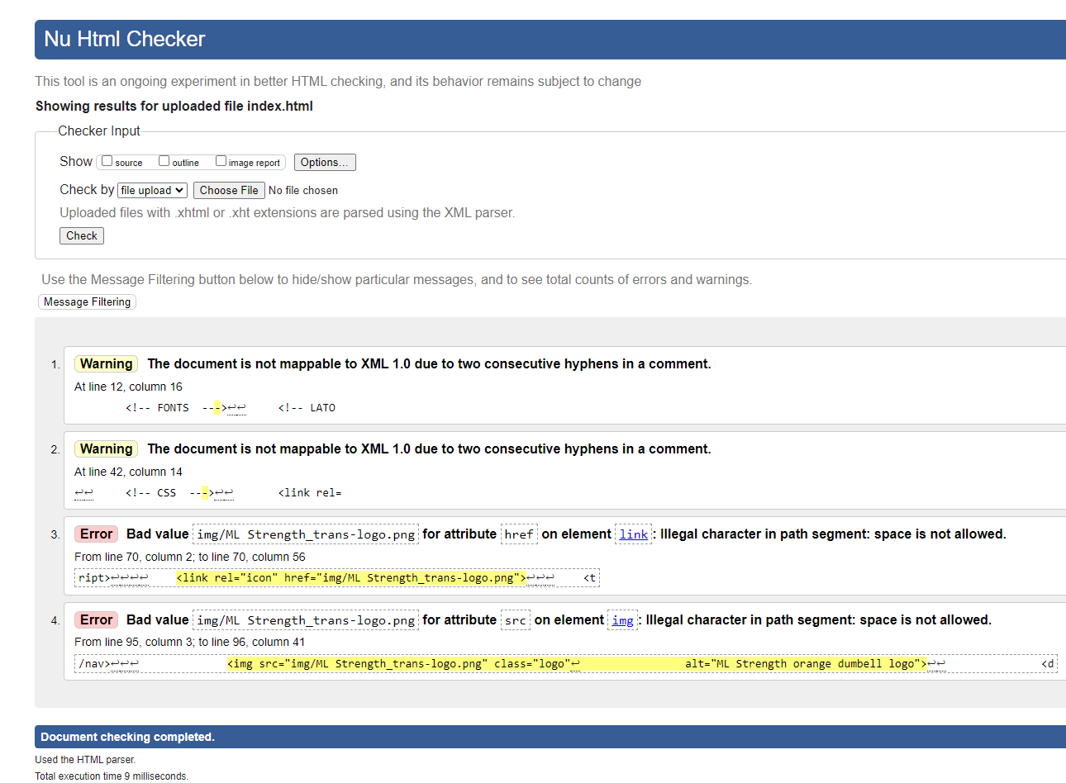

Index Page Test -2

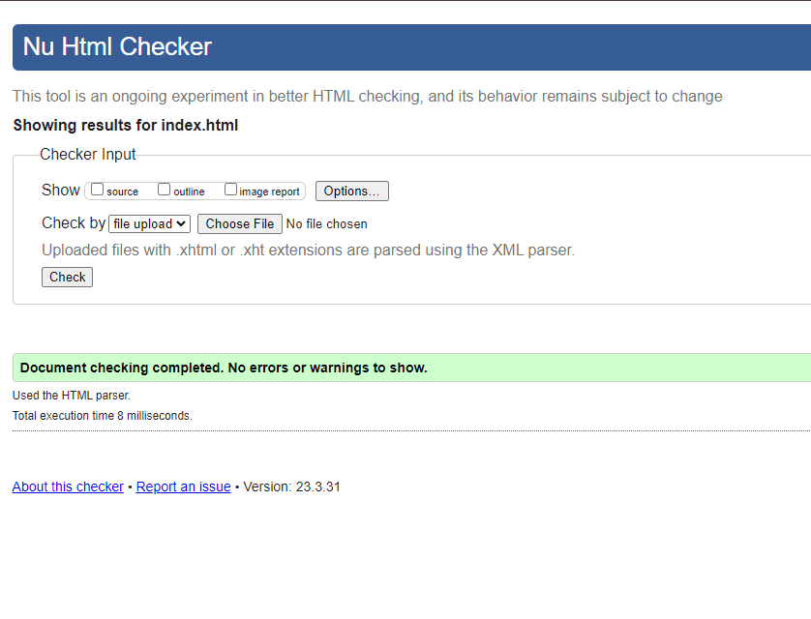

Classes Page Test -1

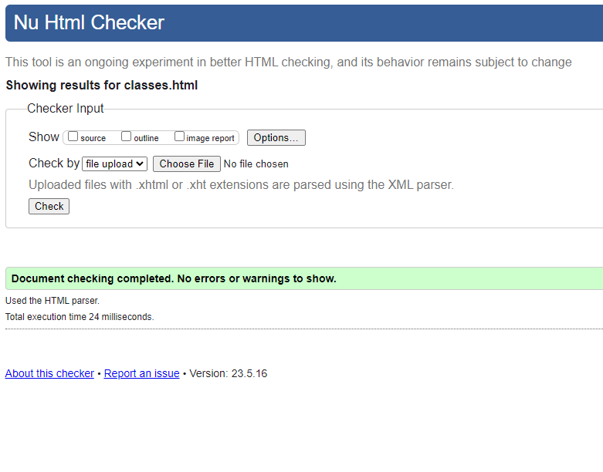

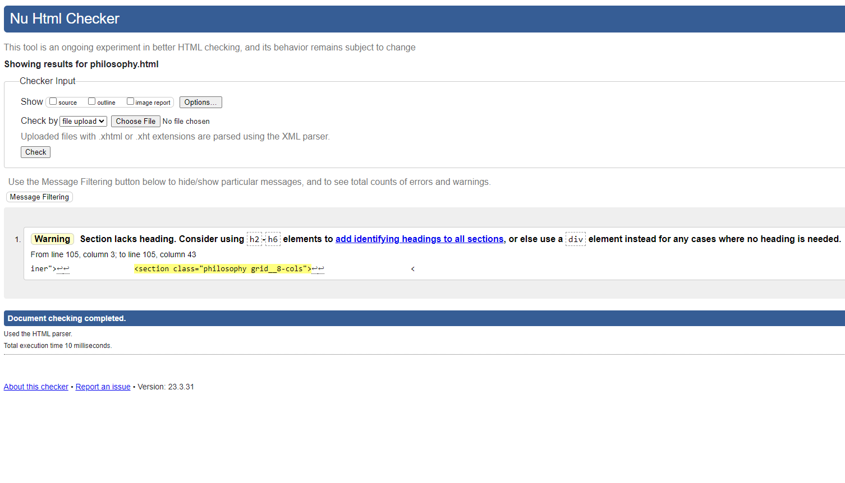Philosophy Page Test -1

Philosophy Page Test-2

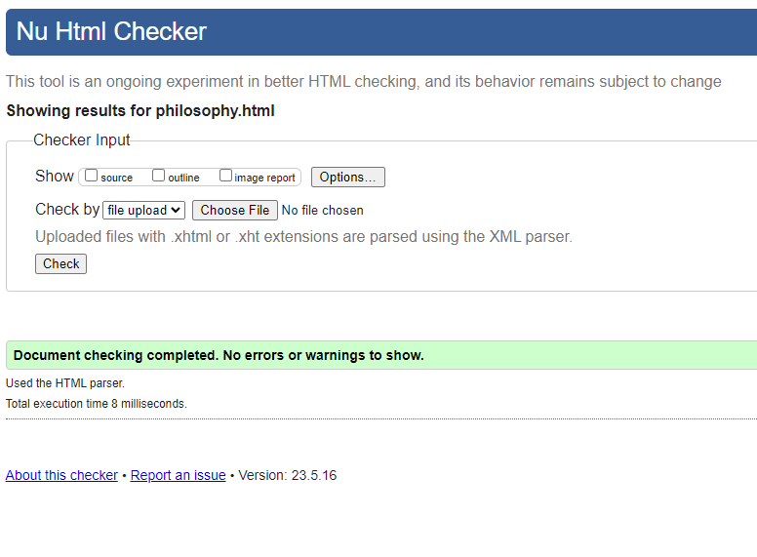

Owner Page Test -1

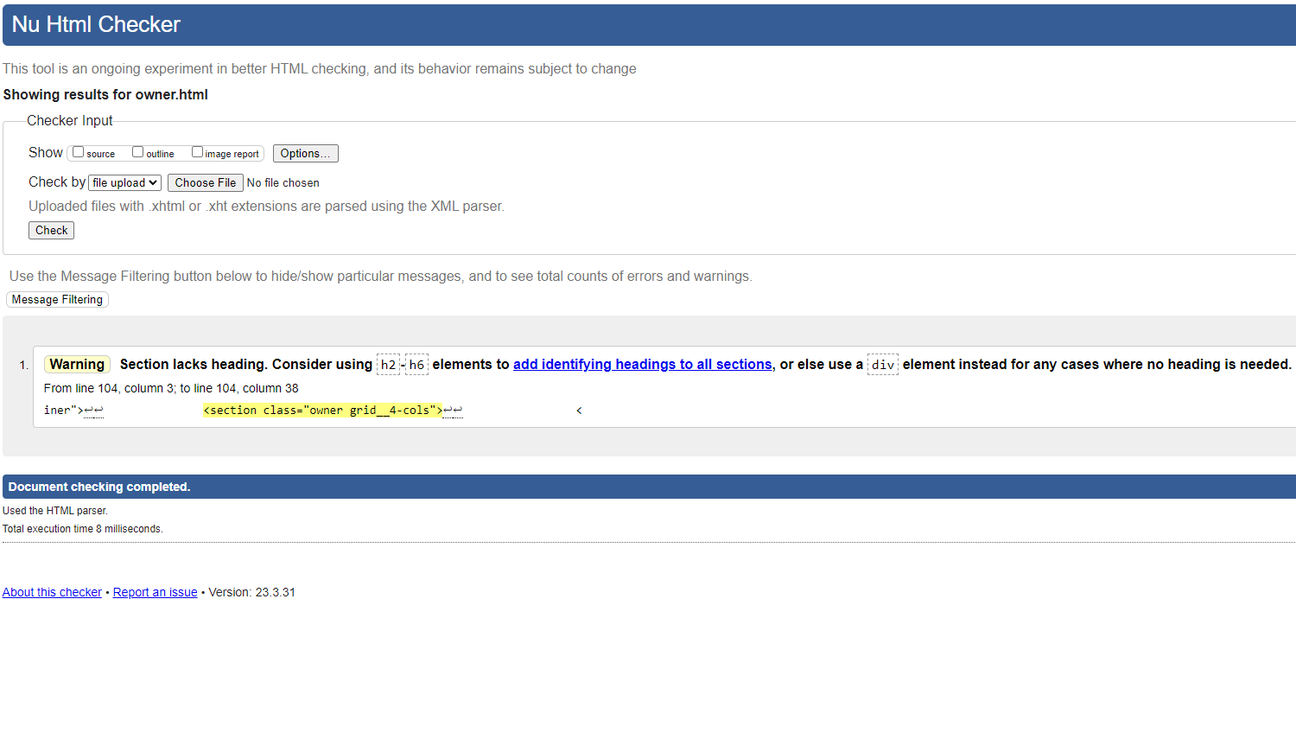

Owner Page Test -2

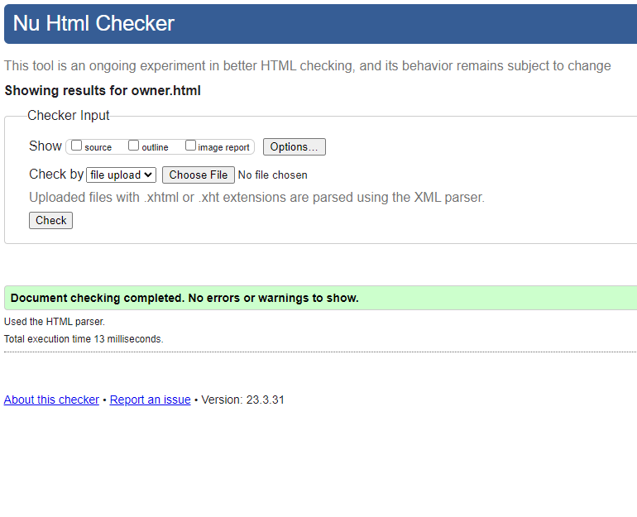

Contact Page Test -1 Screen 1

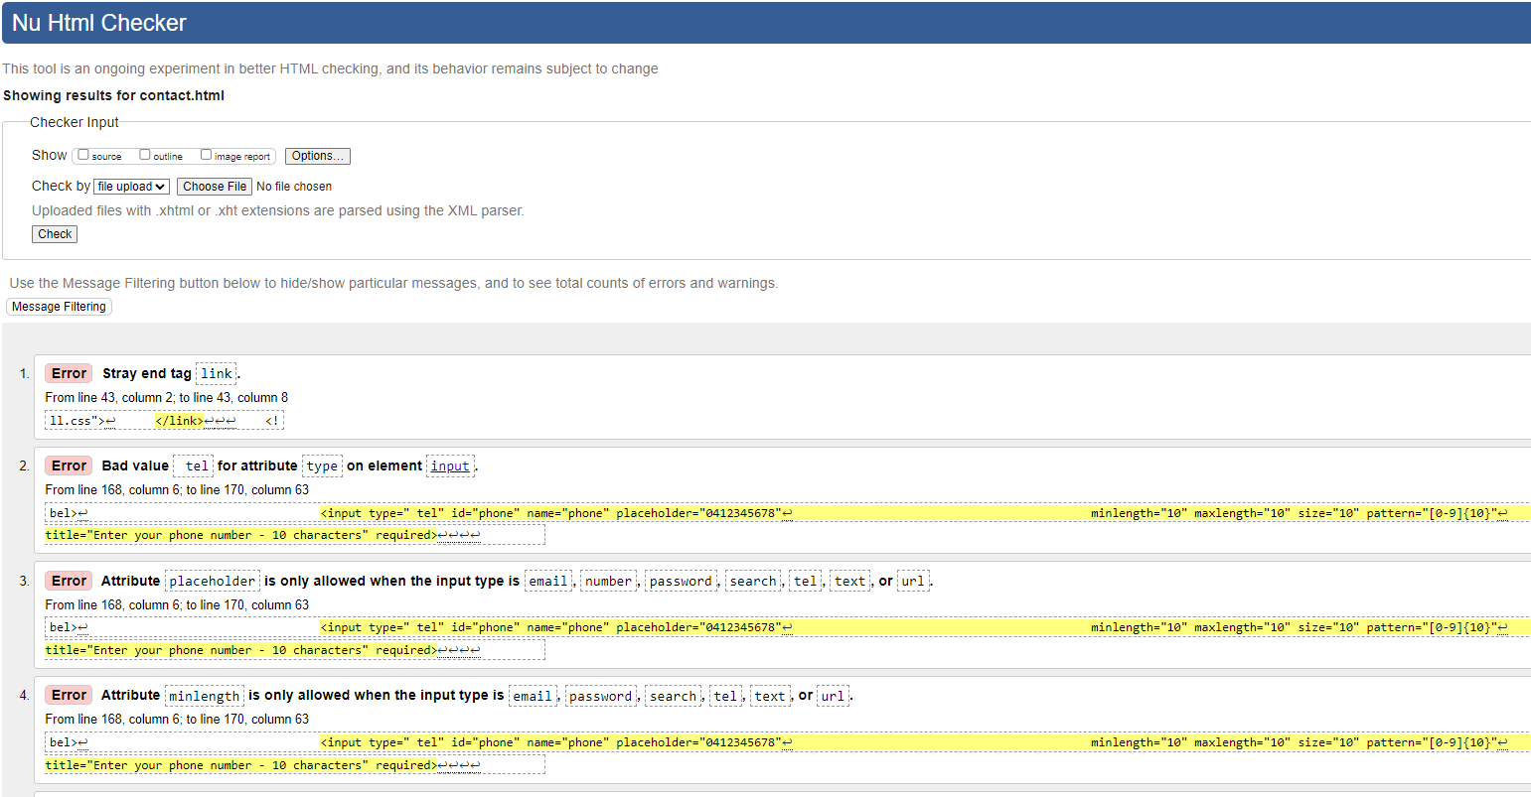

Contact Page Test -1 Screen 2

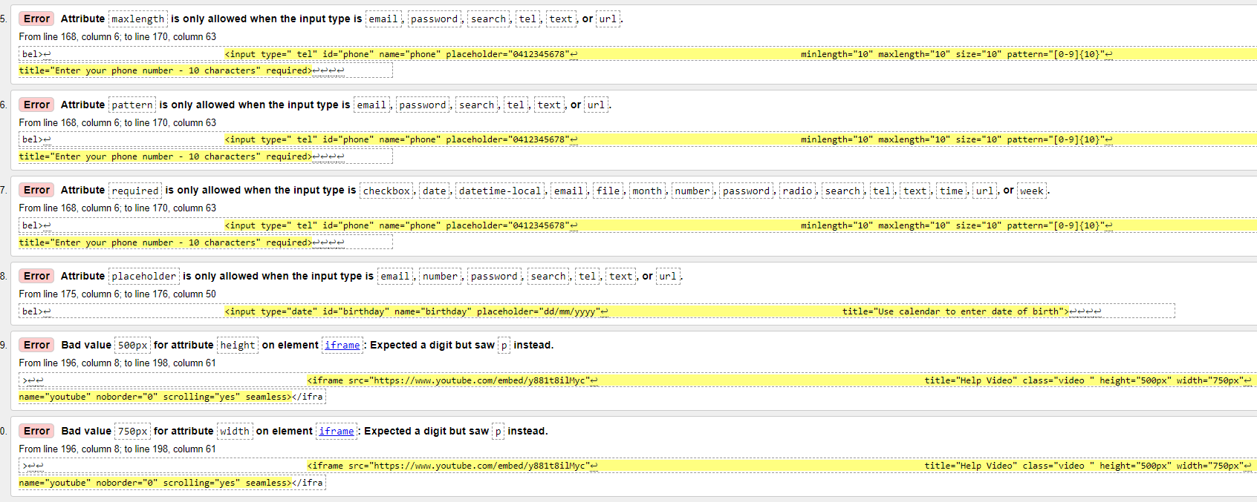

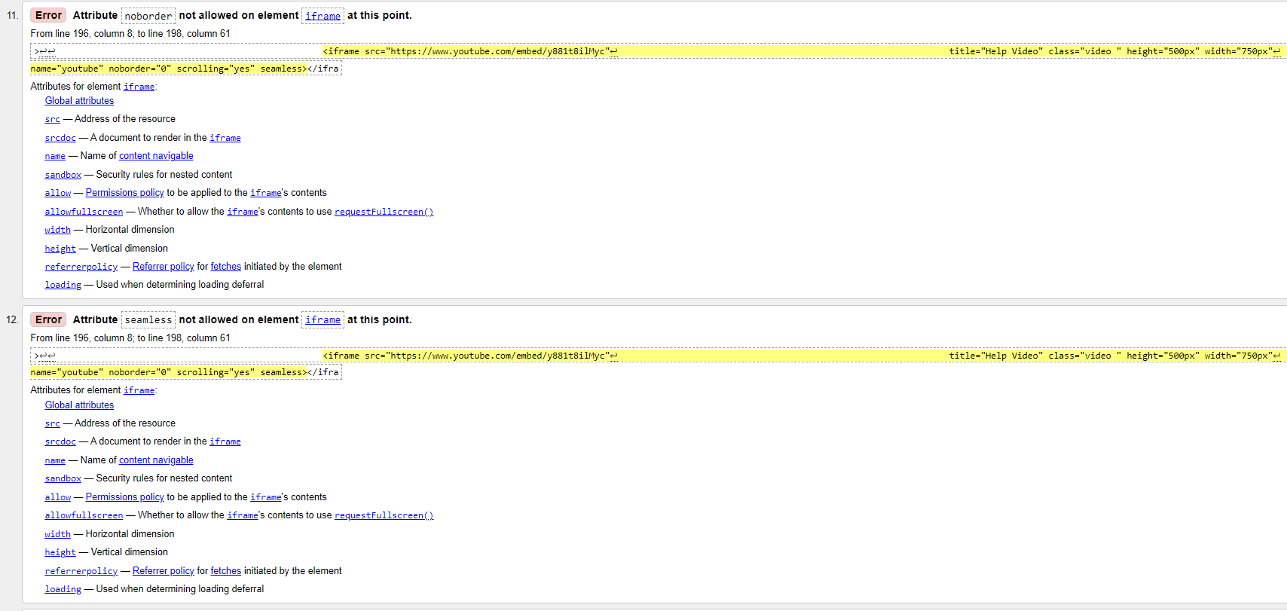Contact Page Test -1 Screen 3

Contact Page Test -1 Screen 4

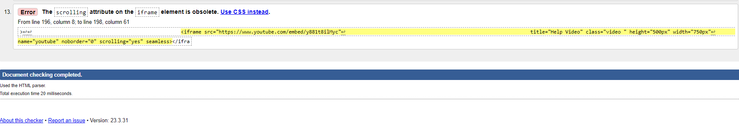

Contact Page Test -2

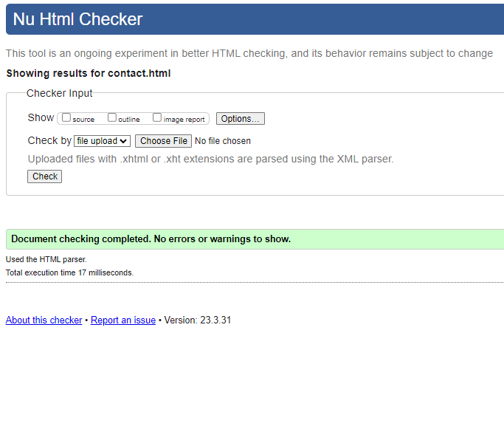

navigation.html test-1

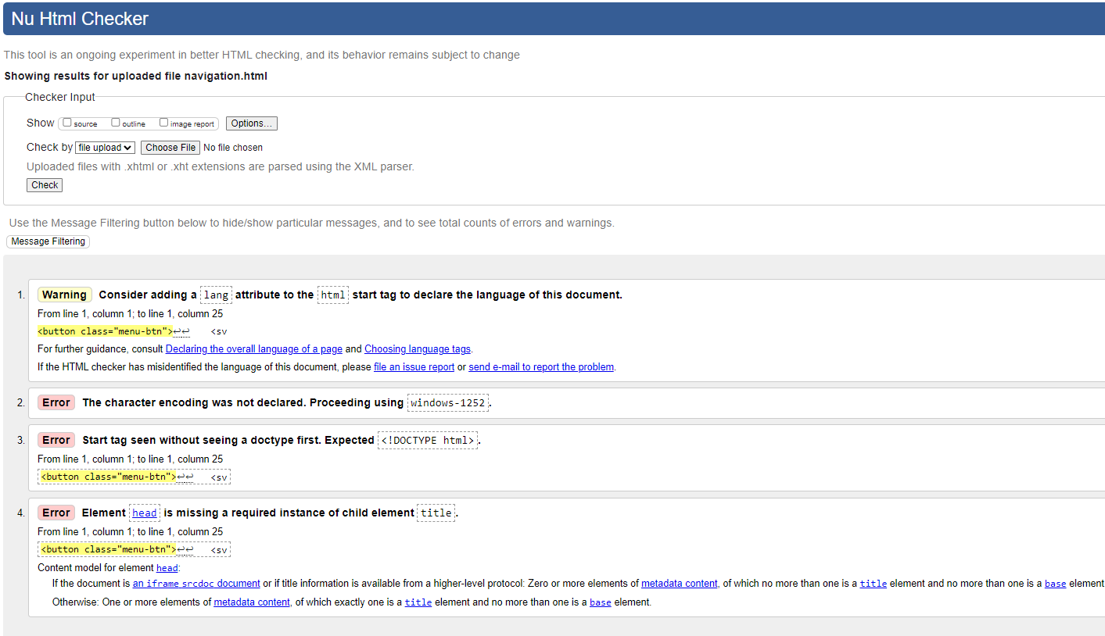

*All issues relate to common file injection and are not needed for this purpose

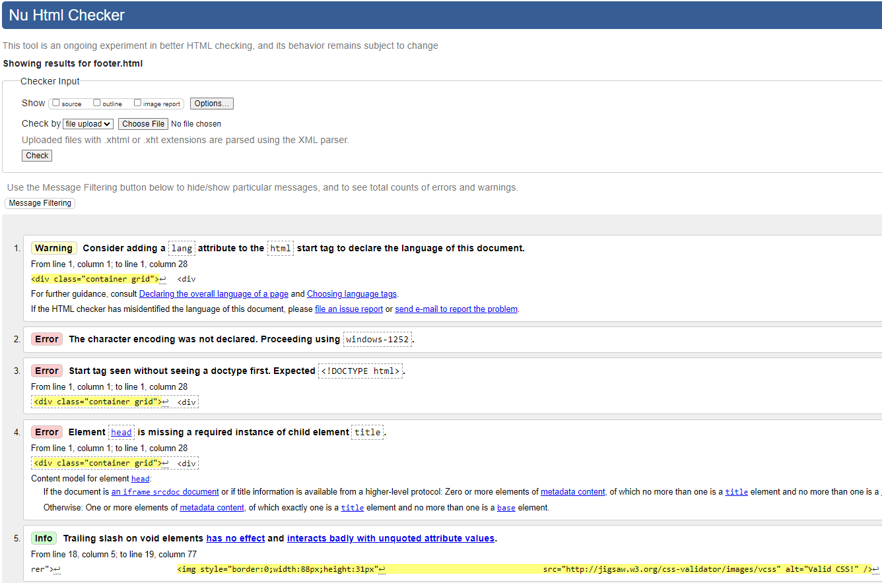Footer.html – Test-1

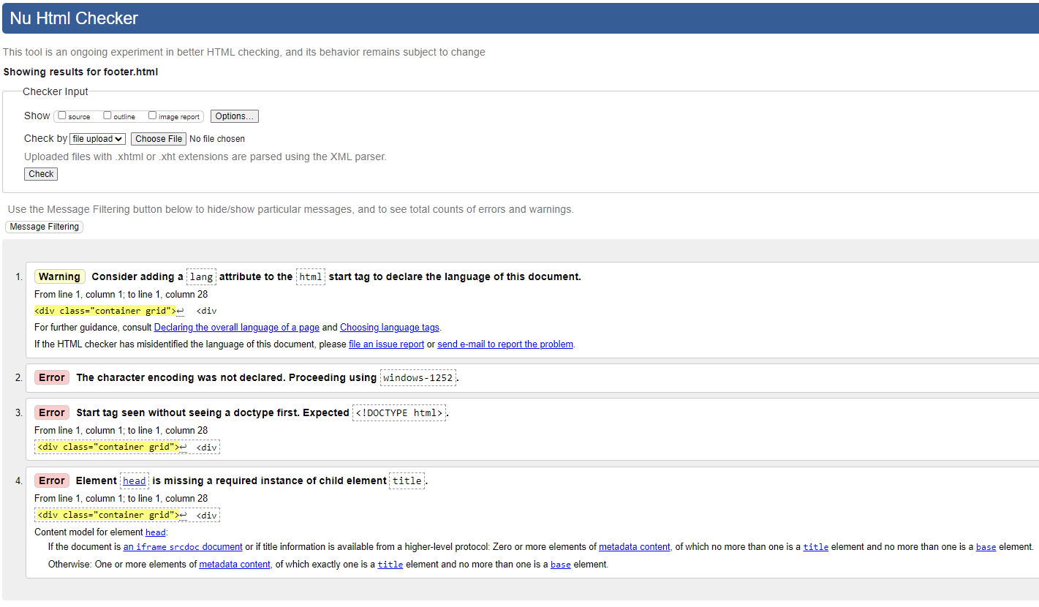Footer.html – Test-2

*All issues relate to common file injection and are not needed for this purpose

**3.3 CSS Validation Testing**

style.css Test -1

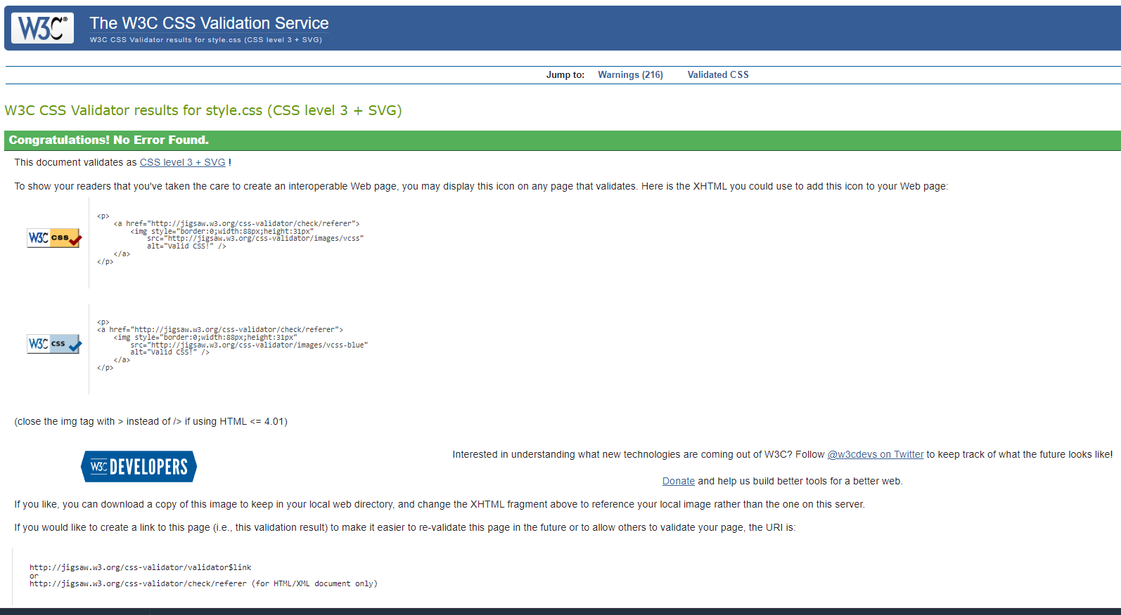

3.4 Browser/Device Testing

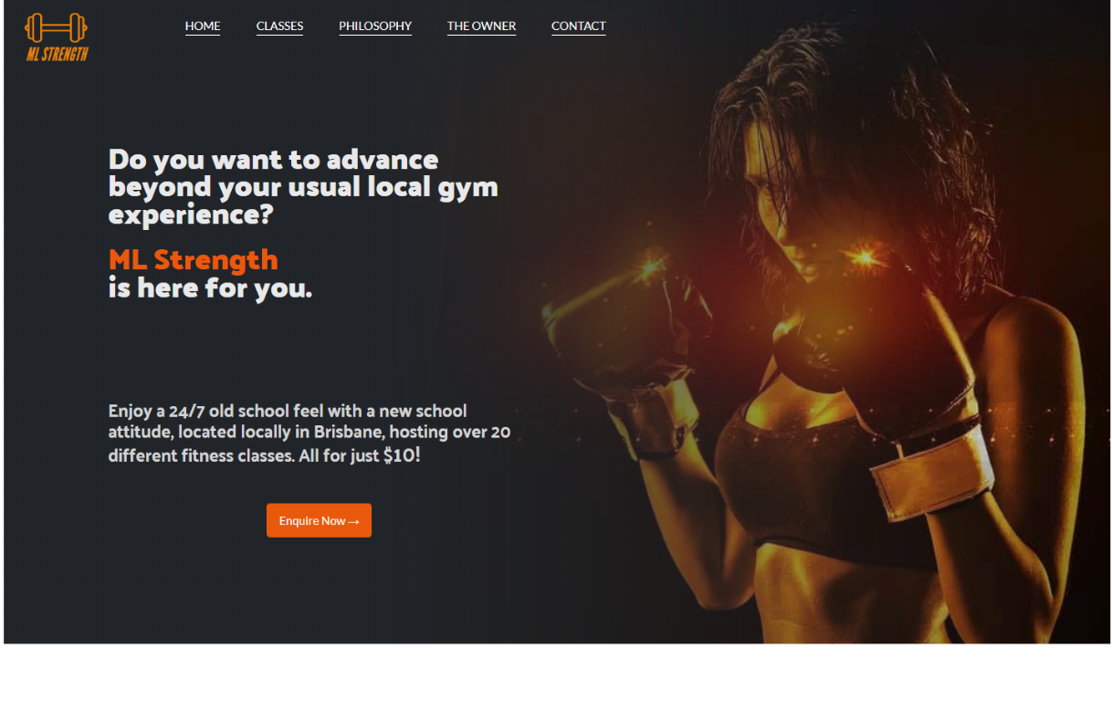

Figure 1 – index.html -Desktop PC

Google Chrome V 113.0.5672.127 (Official Build) (64-bit)

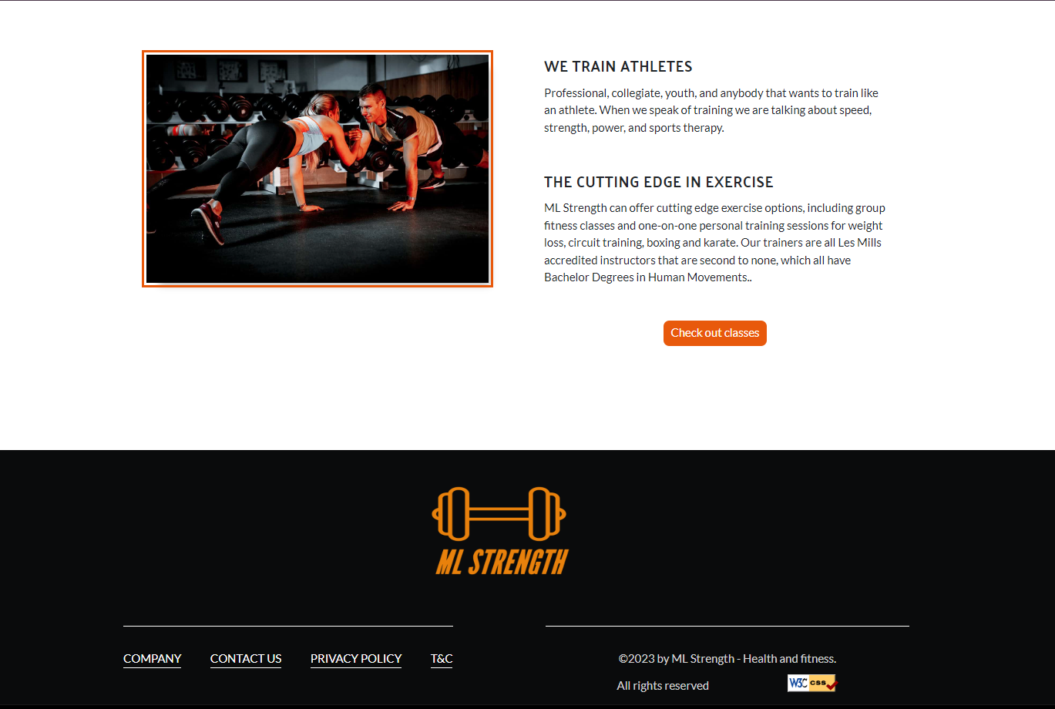

Figure 2 – index.html -Desktop PC

Google Chrome V 113.0.5672.127 (Official Build) (64-bit)

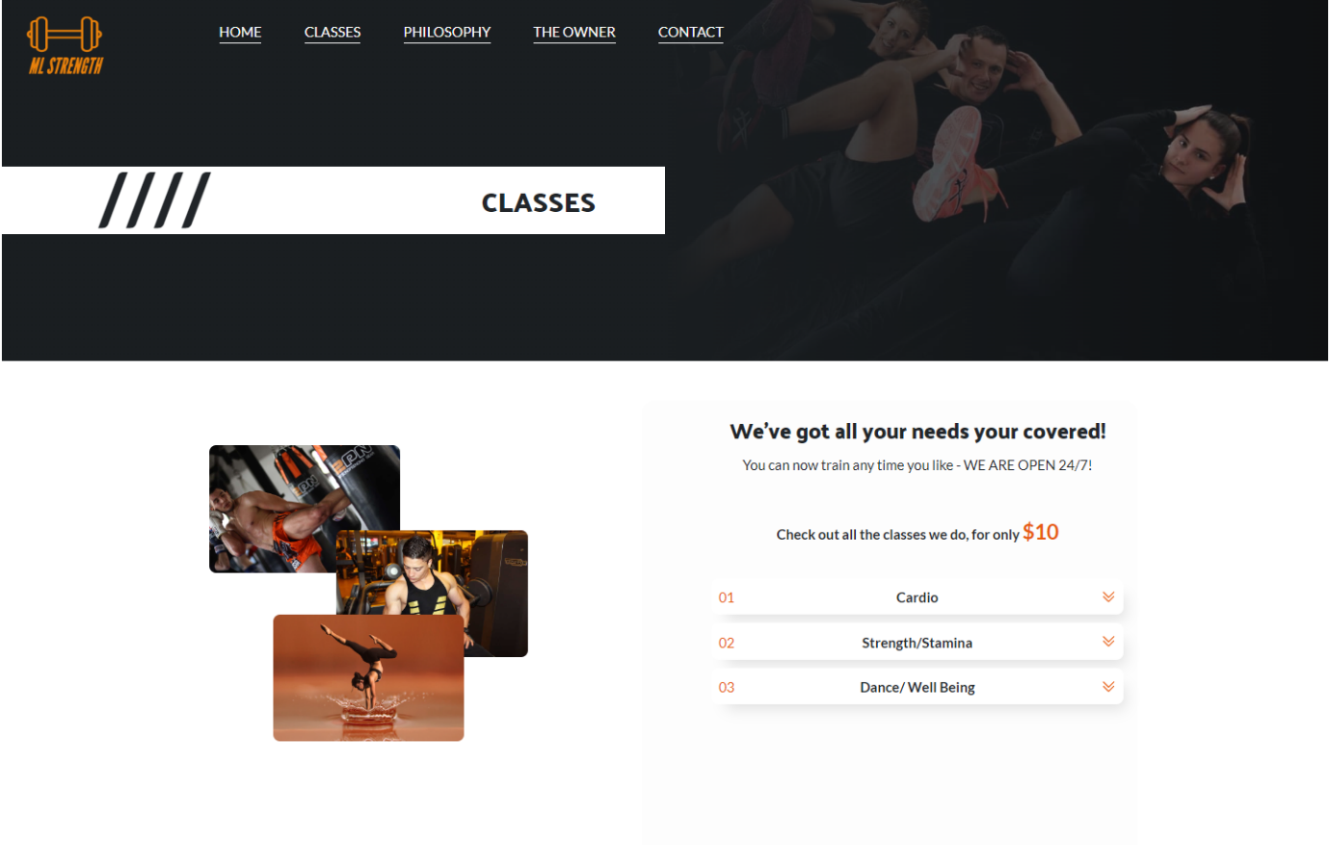Figure 3 – classes.html -Desktop PC

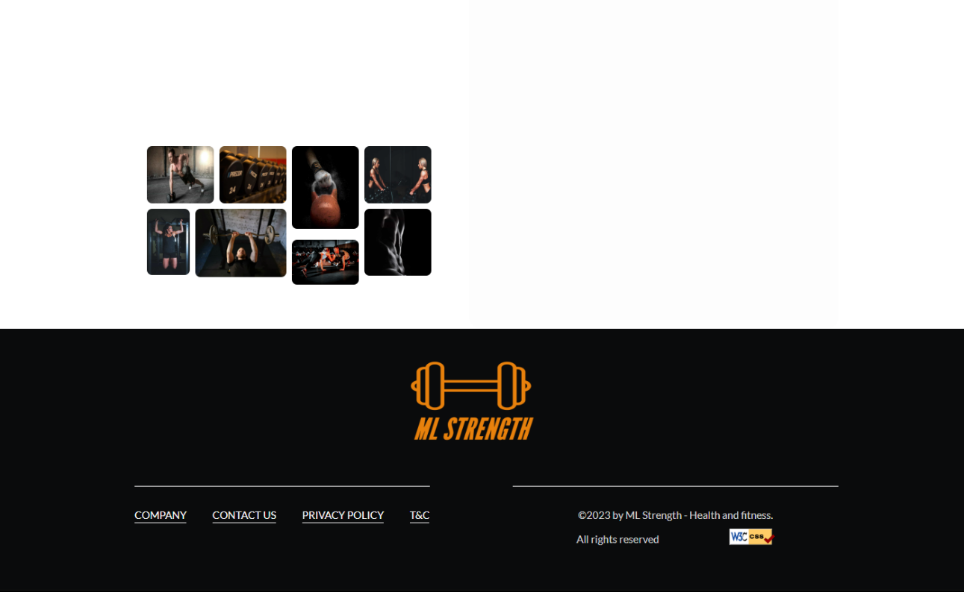Google Chrome V 113.0.5672.127 (Official Build) (64-bit)

Figure 4 – classes.html -Desktop PC

Google Chrome V 113.0.5672.127 (Official Build) (64-bit)

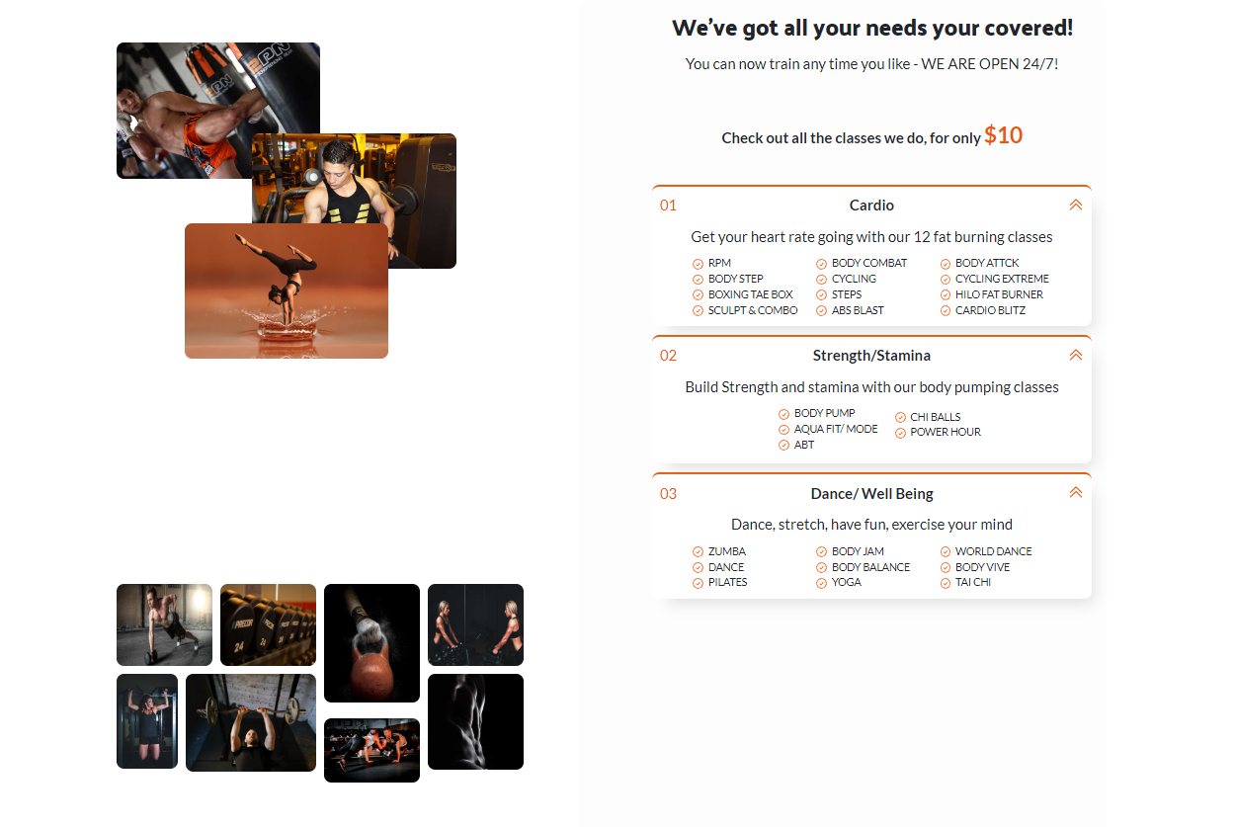

Figure 5 – classes.html “Accordion” -Desktop PC

Google Chrome V 113.0.5672.127 (Official Build) (64-bit)

Figure 6 – philosophy.html -Desktop PC

Google Chrome V 113.0.5672.127 (Official Build) (64-bit)

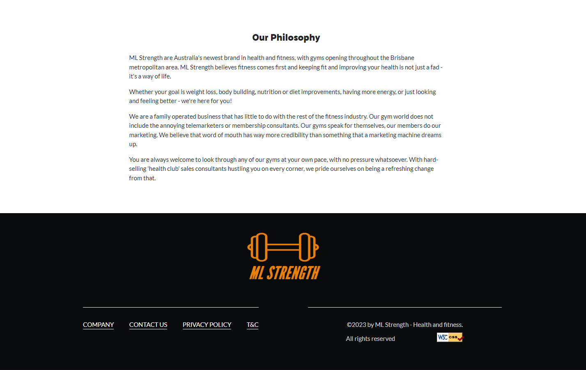

Figure 7 – philosophy.html -Desktop PC

Google Chrome V 113.0.5672.127 (Official Build) (64-bit)

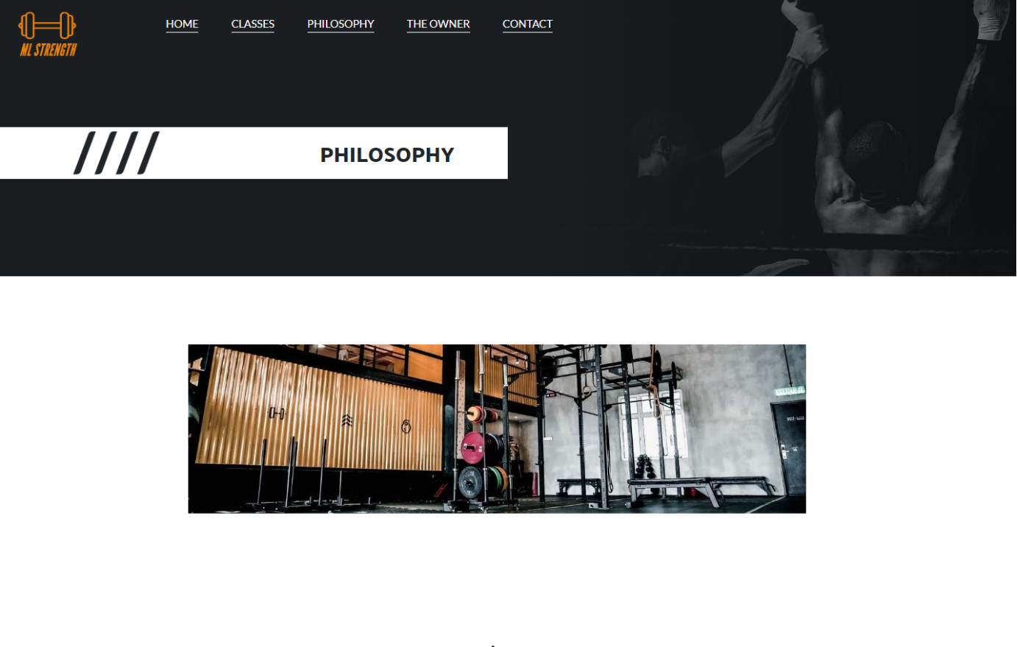

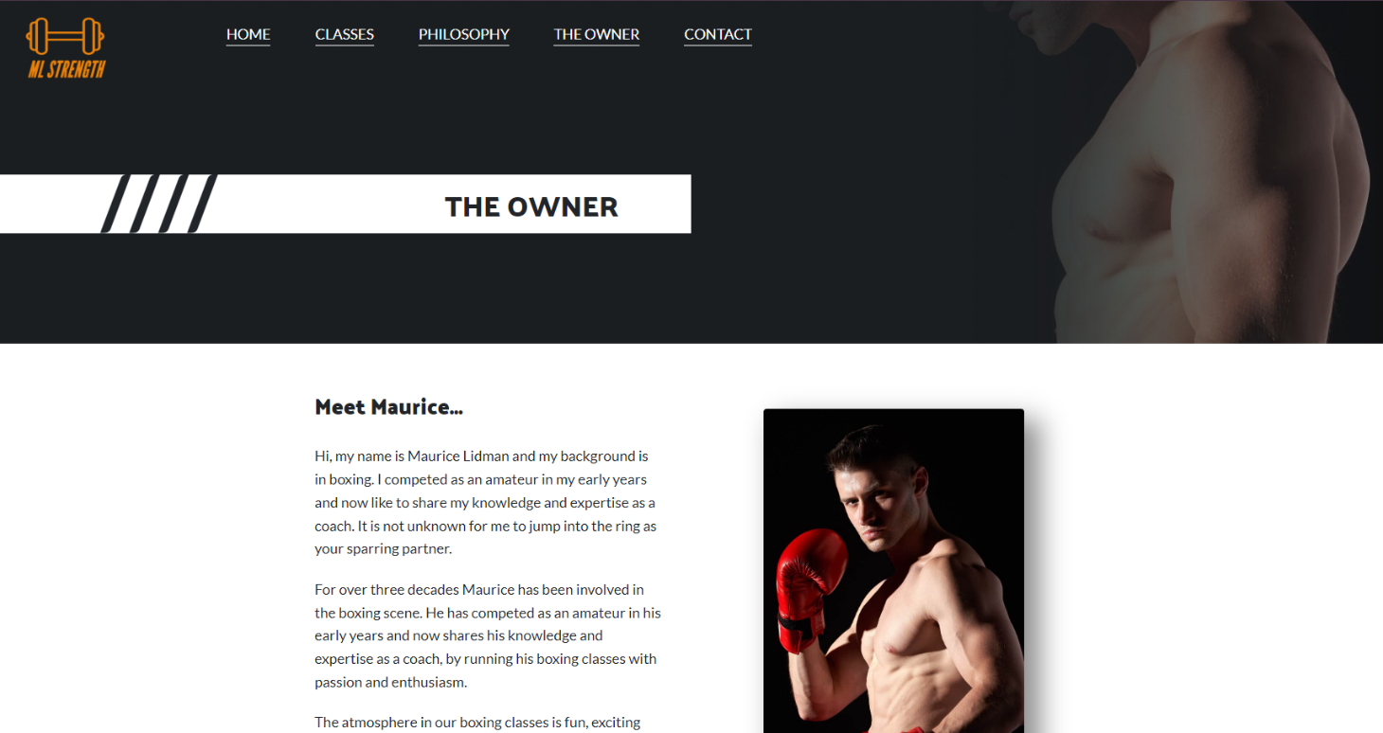

Figure 8 – owner.html -Desktop PC

Google Chrome V 113.0.5672.127 (Official Build) (64-bit)

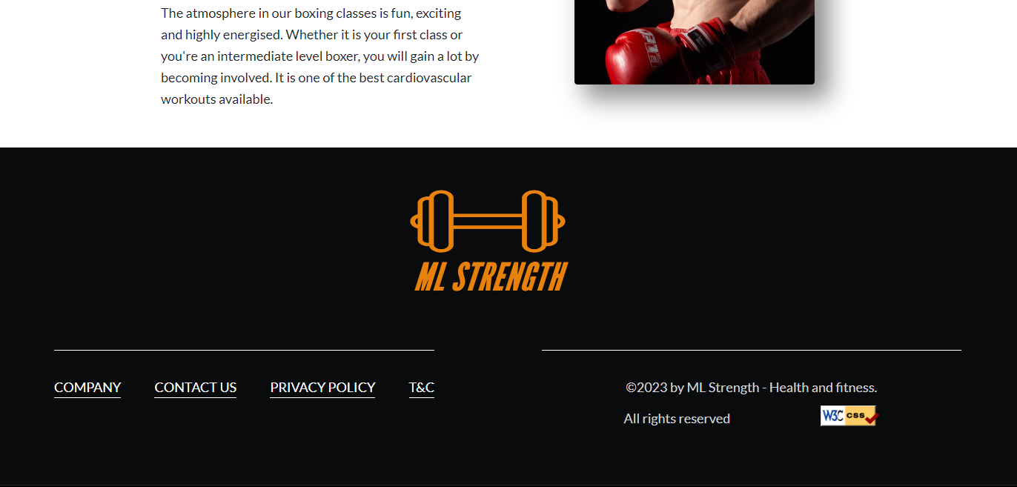

Figure 9 – owner.html -Desktop PC

Google Chrome V 113.0.5672.127 (Official Build) (64-bit)

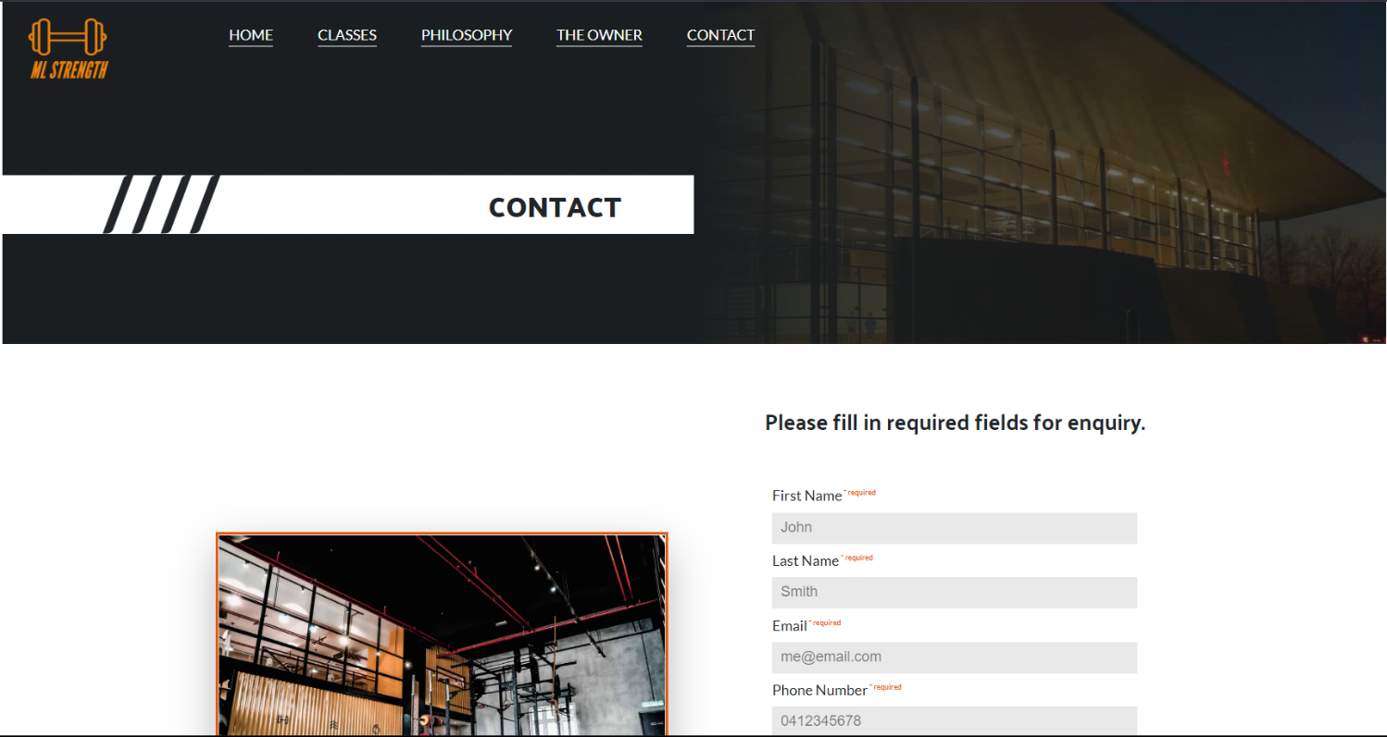

Figure 10 – contact.html -Desktop PC

Google Chrome V 113.0.5672.127 (Official Build) (64-bit)

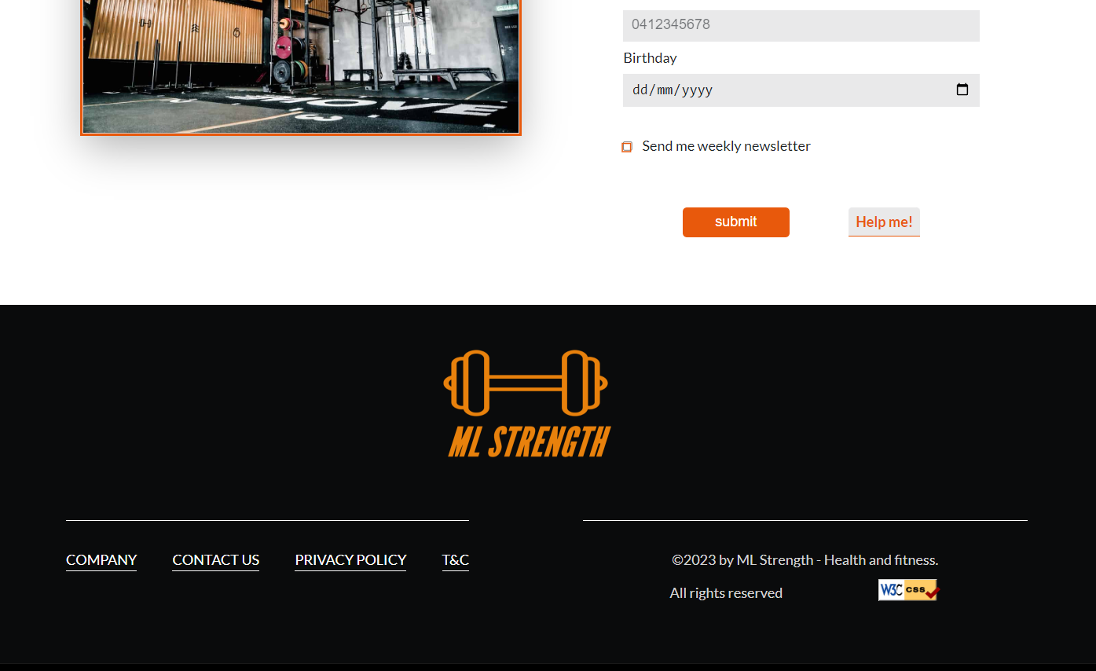

Figure 11 – contact.html -Desktop PC

Google Chrome V 113.0.5672.127 (Official Build) (64-bit)

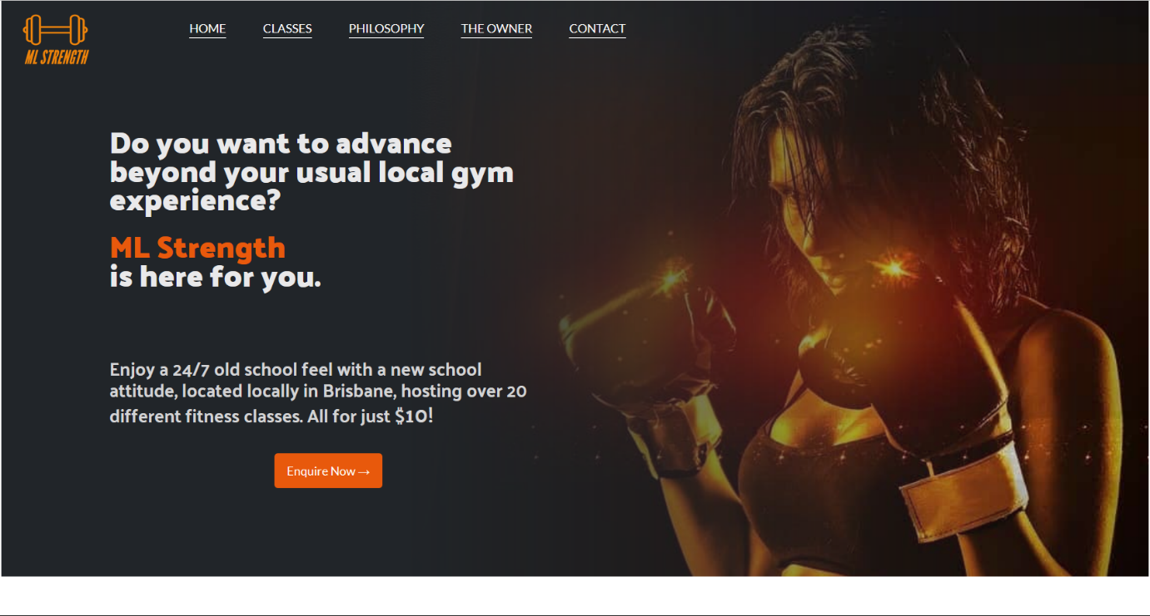

Figure1 – index.html -Desktop PC

Firefox 113.0.1 (64-bit)

Figure 2 – index.html -Desktop PC

Firefox 113.0.1 (64-bit)

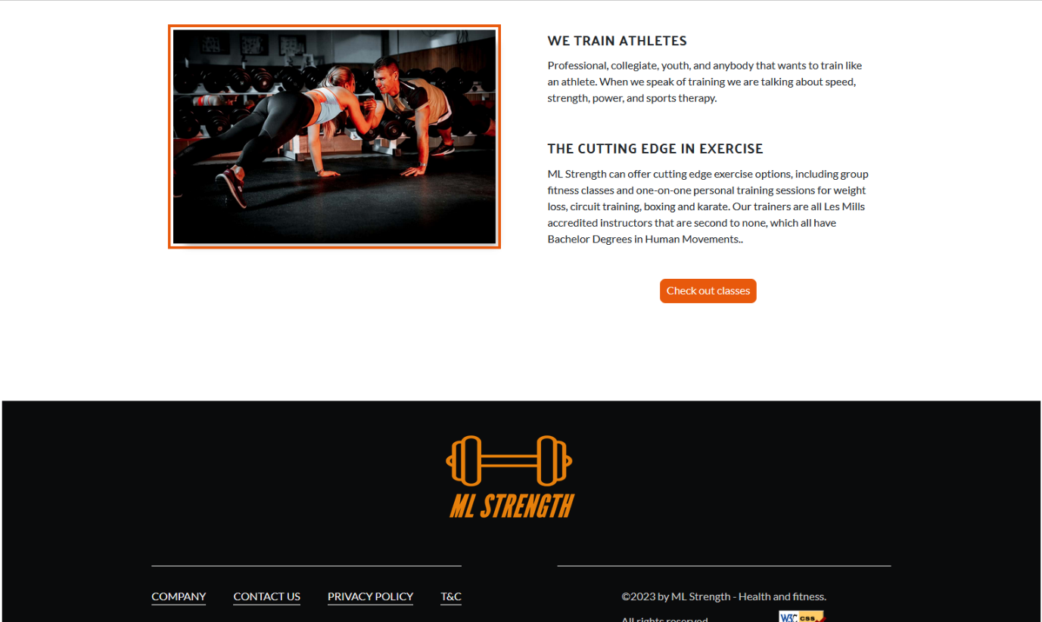

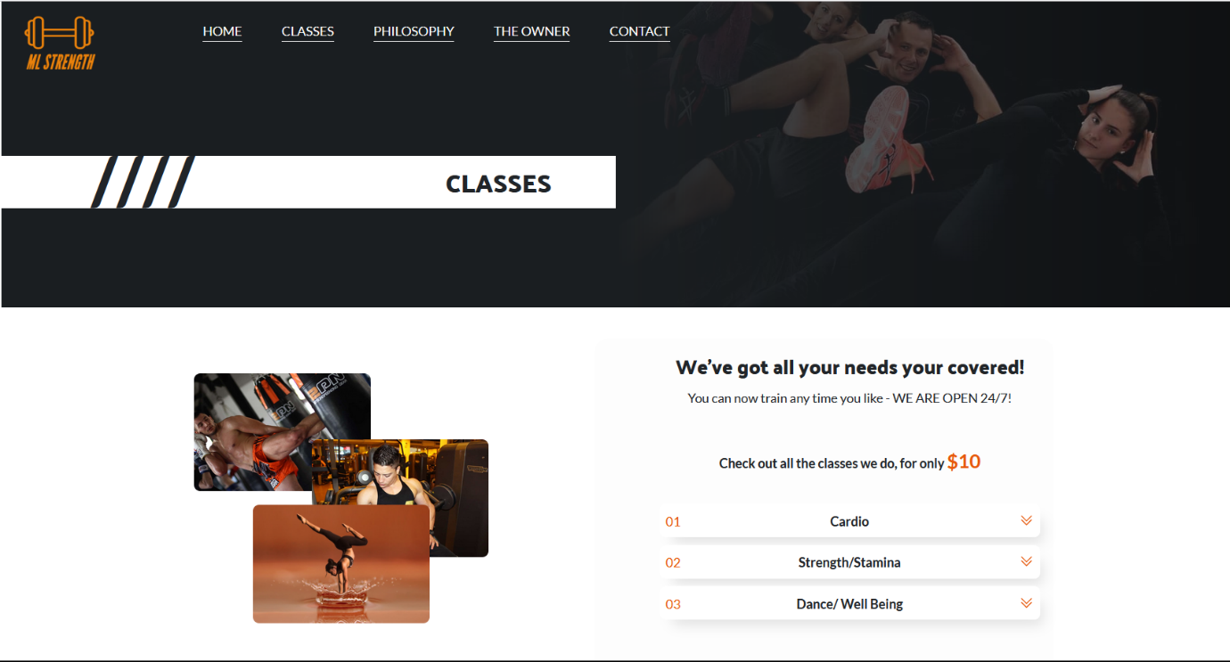

Figure 3 – classes.html -Desktop PC

Firefox 113.0.1 (64-bit)

Figure 4 – classes.html -Desktop PC

Firefox 113.0.1 (64-bit)

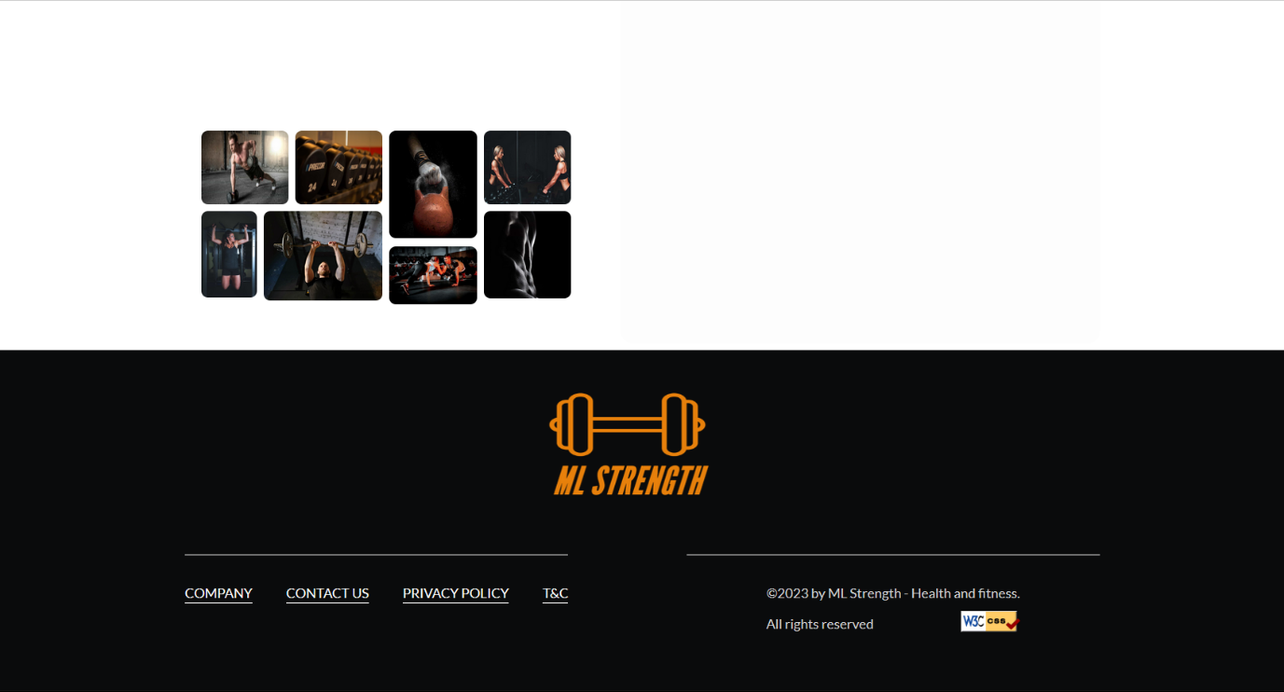

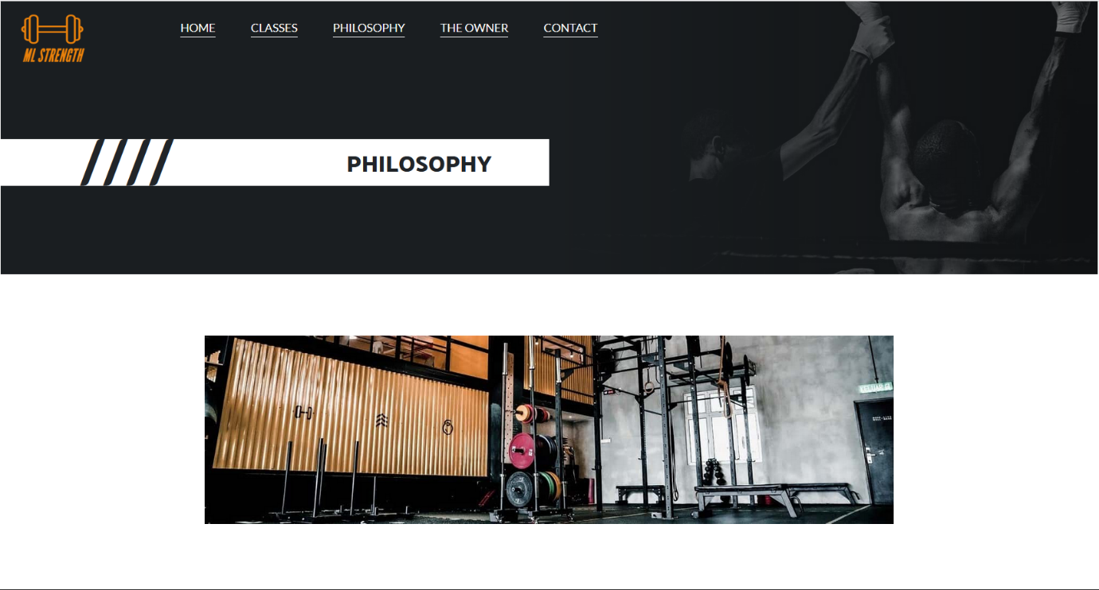Figure 5 – philosophy.html -Desktop PC

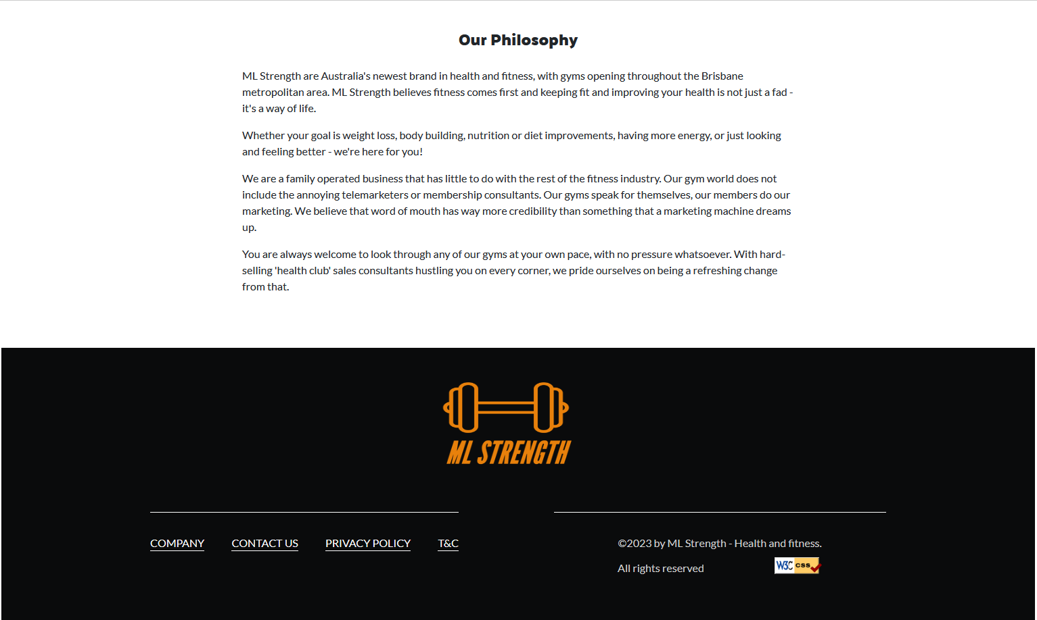Firefox 113.0.1 (64-bit)

Figure 6 – philosophy.html -Desktop PC

Firefox 113.0.1 (64-bit)

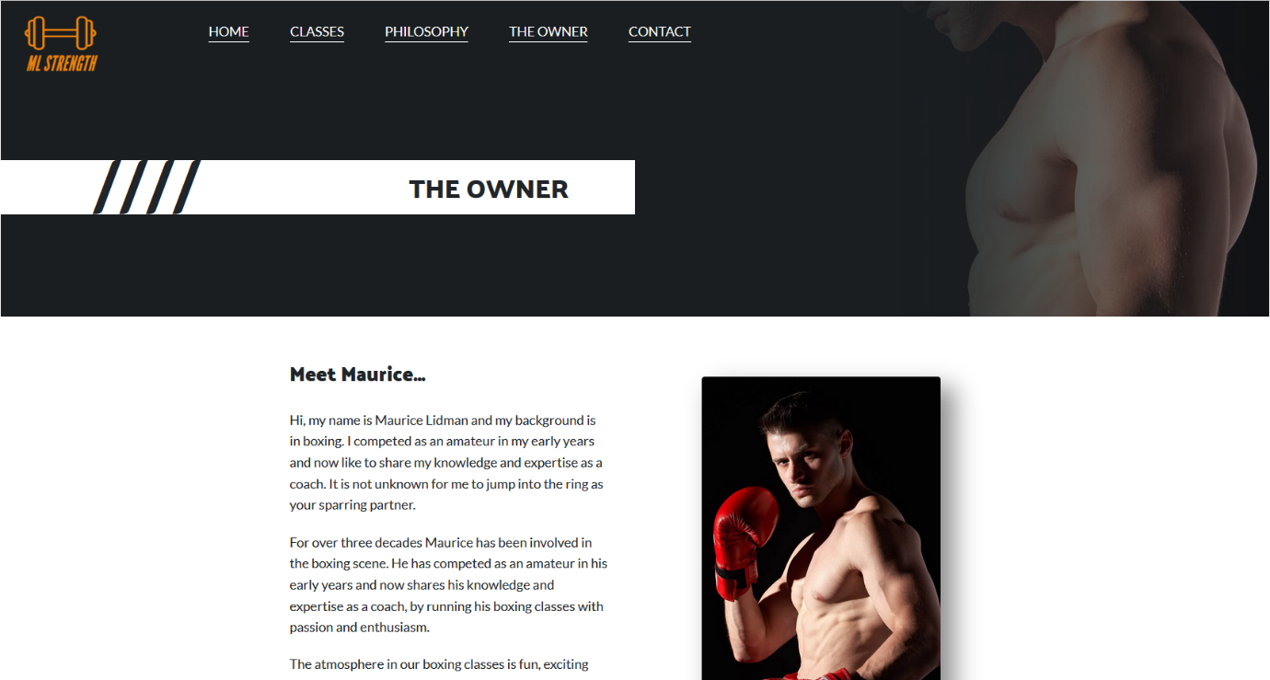

Figure 7 – owner.html -Desktop PC

Firefox 113.0.1 (64-bit)

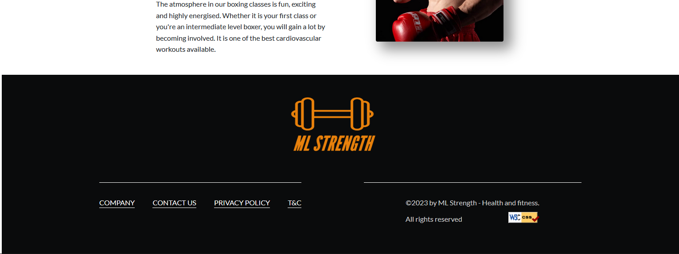

Figure 8 – owner.html -Desktop PC

Firefox 113.0.1 (64-bit)

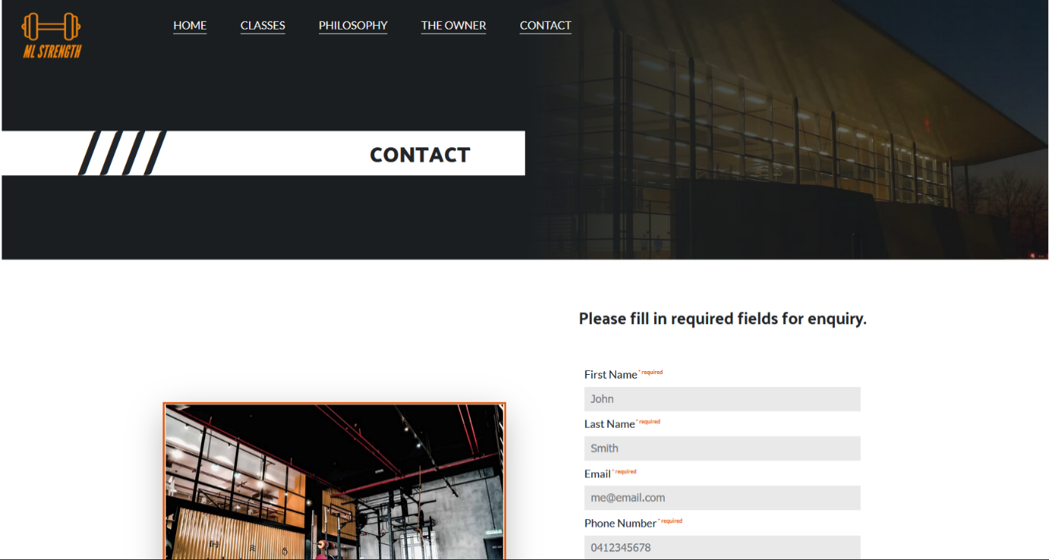

Figure 9 – contact.html -Desktop PC

Firefox 113.0.1 (64-bit)

Figure 10 – contact.html -Desktop PC

Firefox 113.0.1 (64-bit)

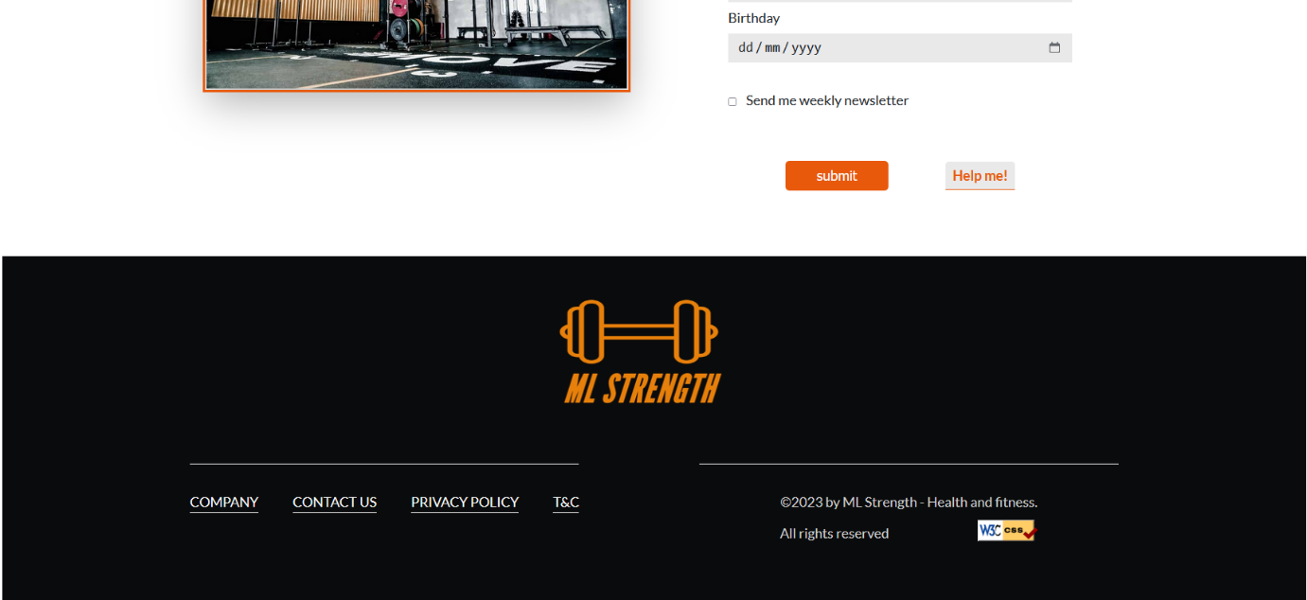

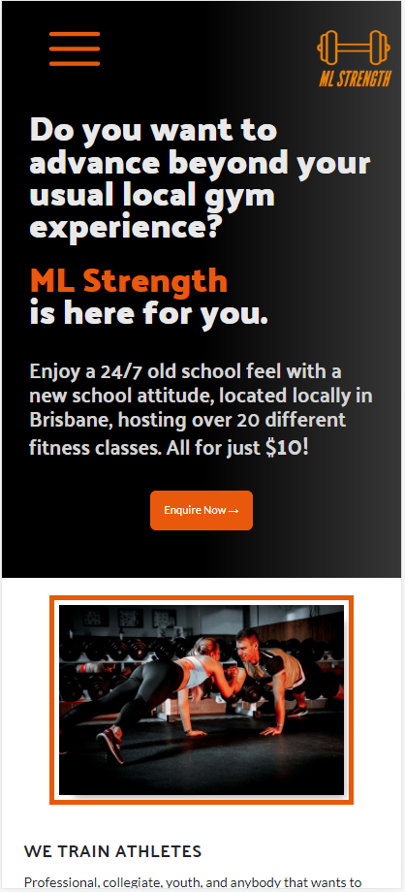

Figure 1 – index.html -Mobile device

Samsung Galaxy s20 ultra

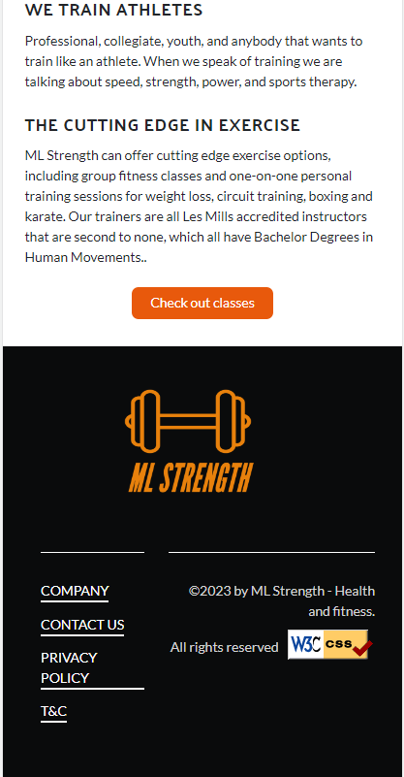

Figure 2 – index.html -Mobile device

Samsung Galaxy s20 ultra

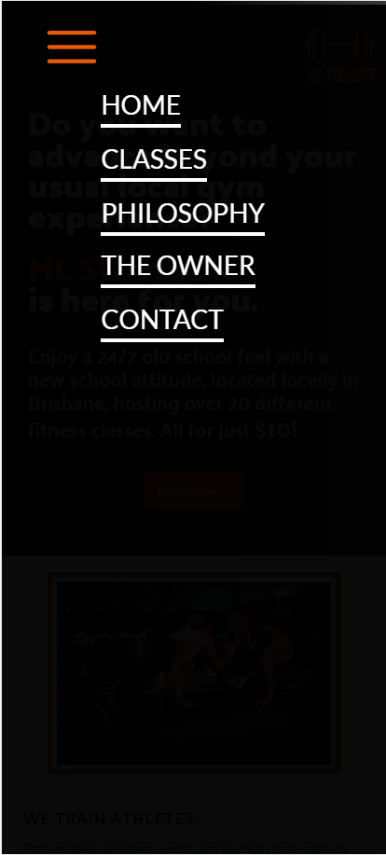

Figure 3 – Menu -Mobile device

Samsung Galaxy s20 ultra

Figure 4 – classes.html -Mobile device

Samsung Galaxy s20 ultra

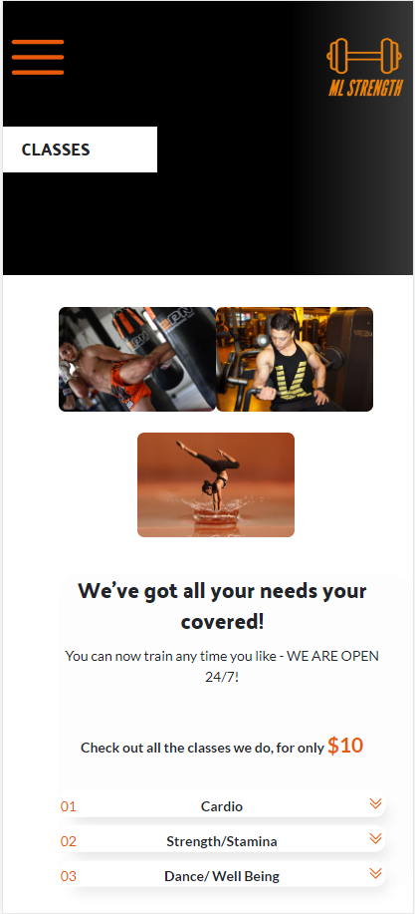

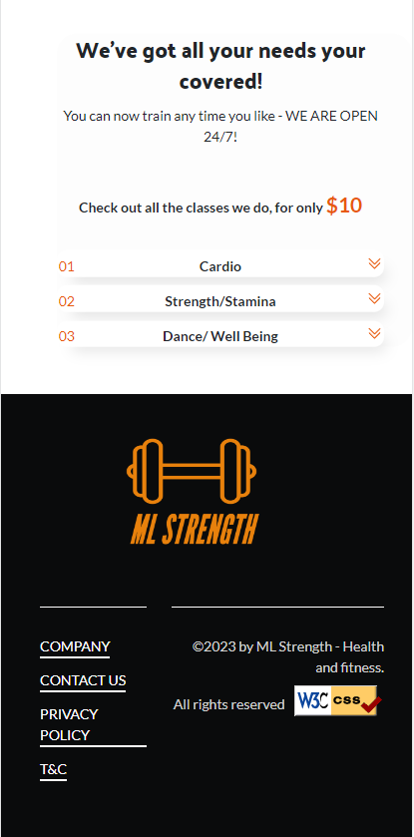

Figure 5 – classes.html -Mobile device

Samsung Galaxy s20 ultra

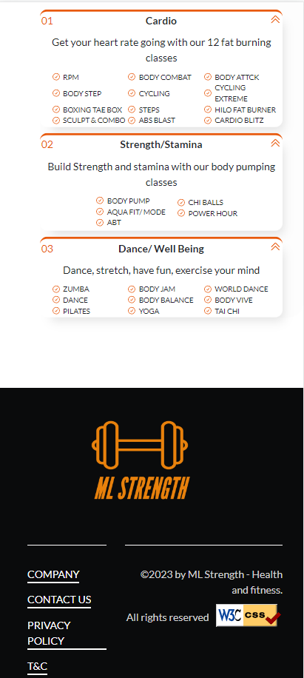

Figure 6 – accordion -Mobile device

Samsung Galaxy s20 ultra

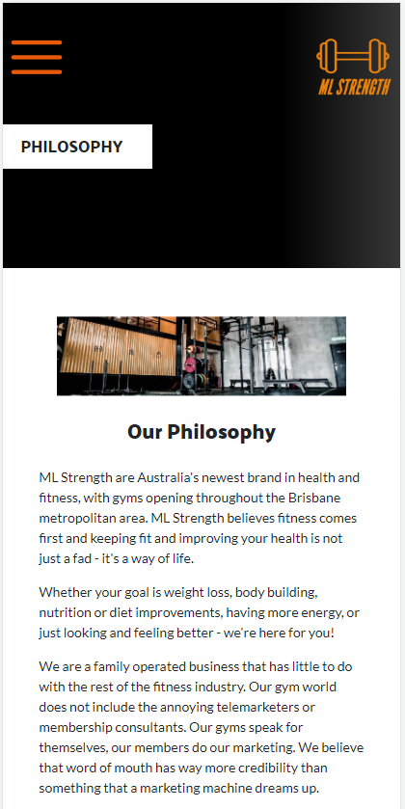

Figure 7 – philosophy.html -Mobile device

Samsung Galaxy s20 ultra

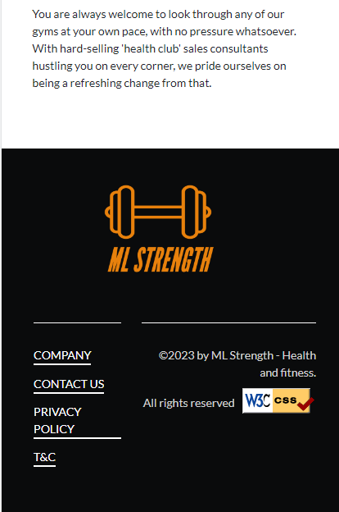

Figure 8 – philosophy.html -Mobile device

Samsung Galaxy s20 ultra

Figure 9 – owner.html -Mobile device

Samsung Galaxy s20 ultra

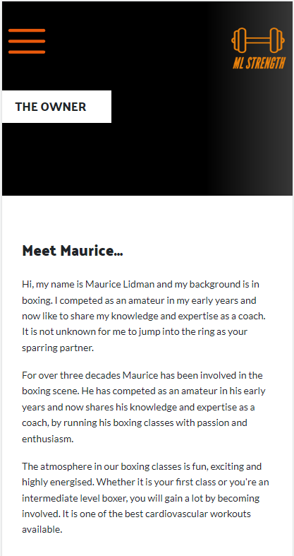

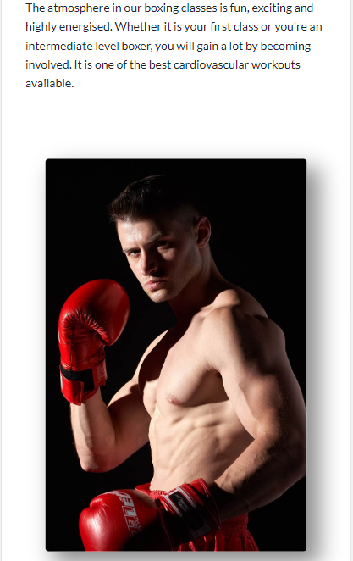

Figure 10 – owner.html -Mobile device

Samsung Galaxy s20 ultra

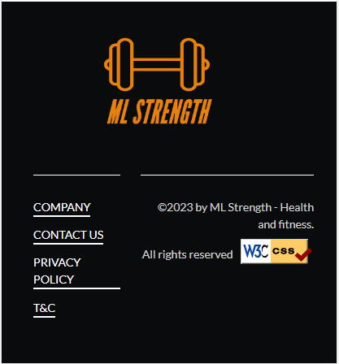

Figure 11 - owner.html -Mobile device

Samsung Galaxy s20 ultra

Figure 12 - contact.html -Mobile device

Samsung Galaxy s20 ultra

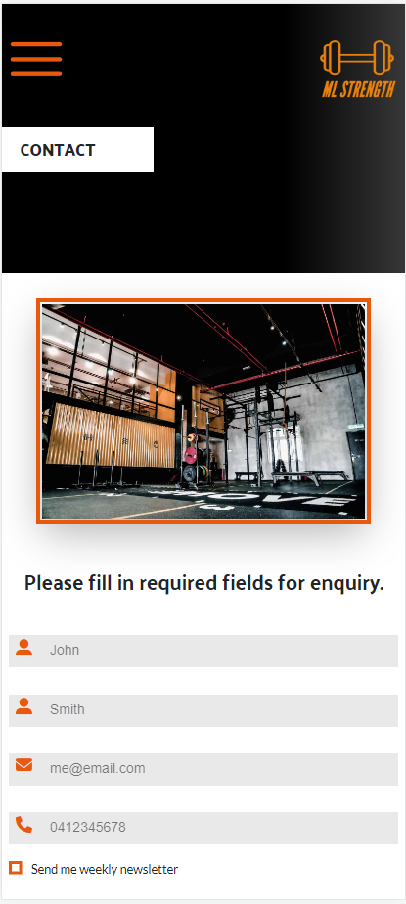

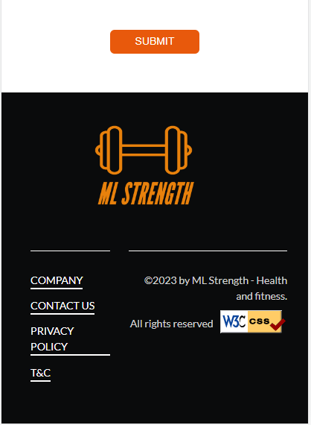

Figure 13 – contact.html -Mobile device

Samsung Galaxy s20 ultra

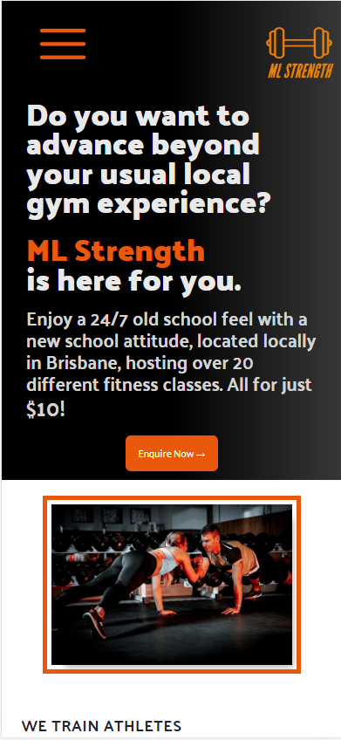

Figure 1 – index.html -Mobile device

iPhone 12 pro

Figure 2 – index.html -Mobile device

iPhone 12 pro

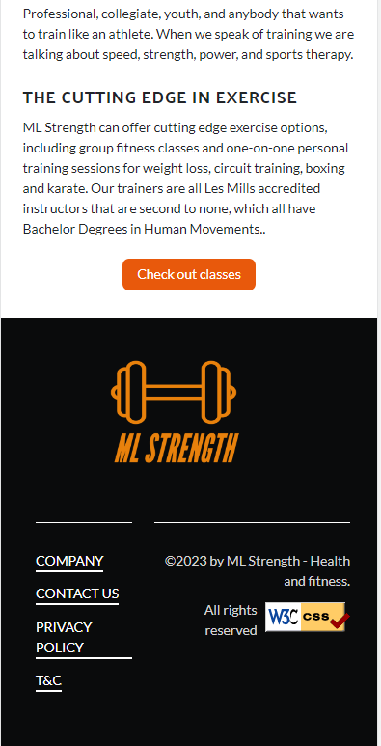

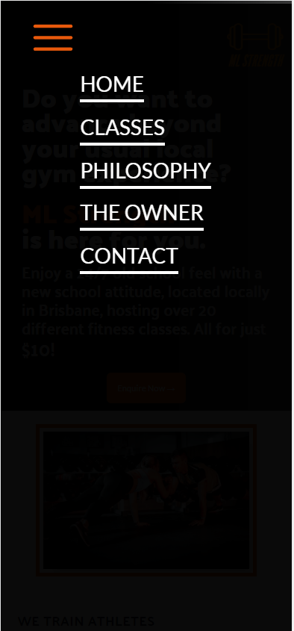

Figure 3 – Menu -Mobile device

iPhone 12 pro

Figure 4 – classes.html -Mobile device

iPhone 12 pro

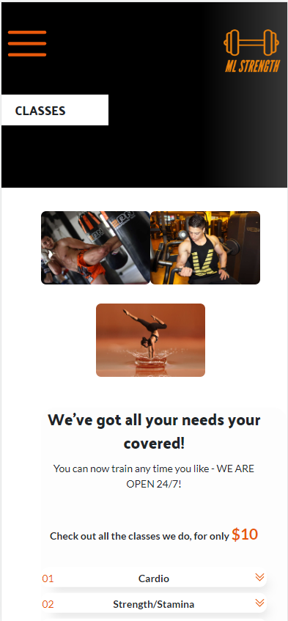

Figure 5 – classes.html -Mobile device

iPhone 12 pro

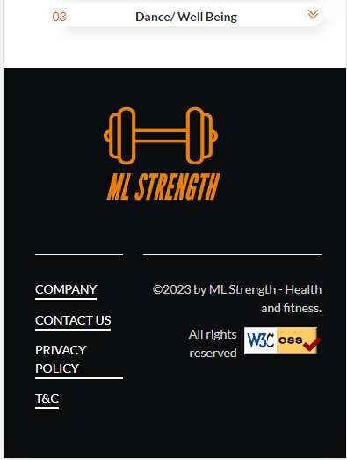

Figure 6 – accordion -Mobile device

iPhone 12 pro

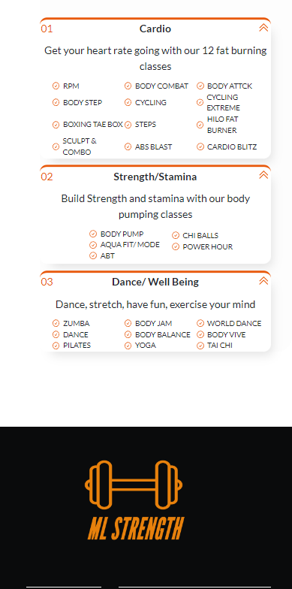

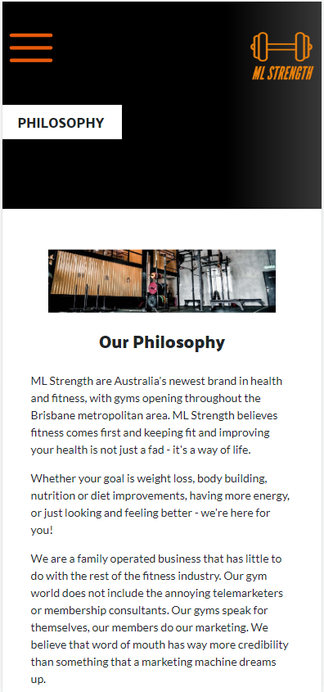

Figure 7 – philosophy.html -Mobile device

iPhone 12 pro

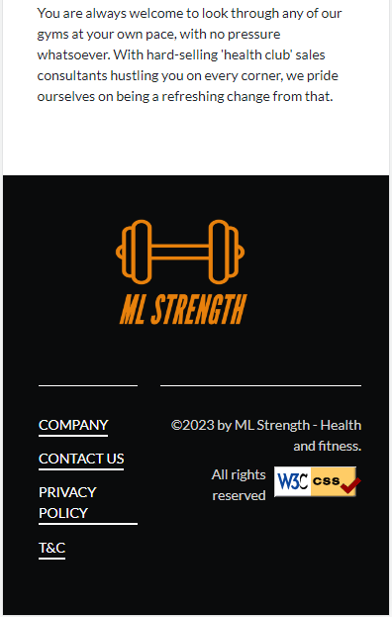

Figure 8 – philosophy.html -Mobile device

iPhone 12 pro

*.*

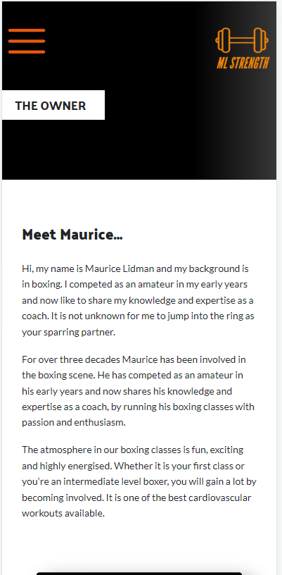

Figure 9 – owner.html -Mobile device

iPhone 12 pro

**

Figure 10 – owner.html -Mobile device

iPhone 12 pro

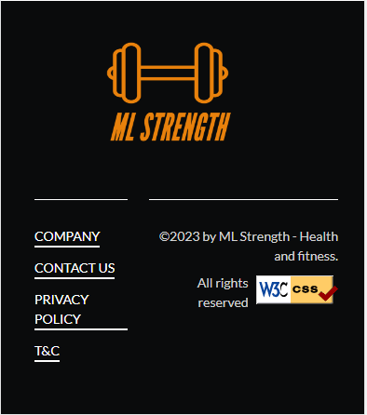

Figure 11 – owner.html -Mobile device

iPhone 12 pro

Figure 12 – contact.html -Mobile device

iPhone 12 pro

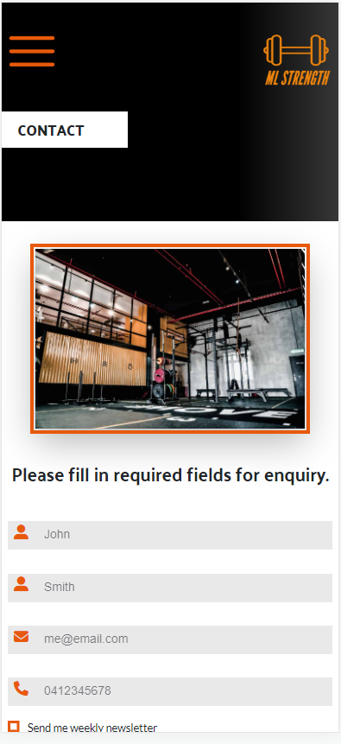

Figure 13 – contact.html -Mobile device

iPhone 12 pro

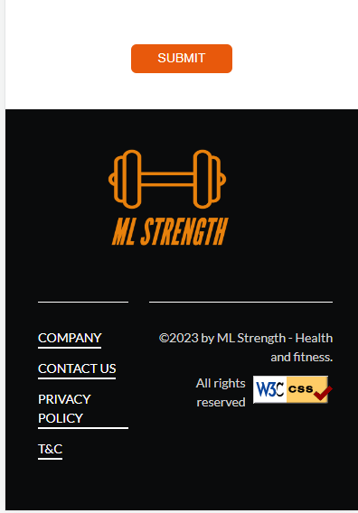

3.5 Autoprefixer

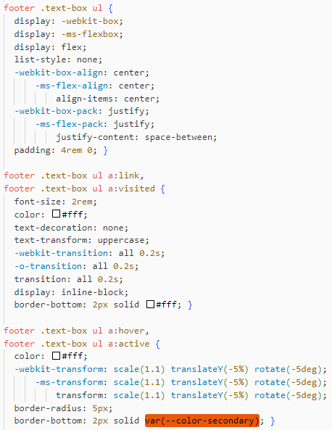

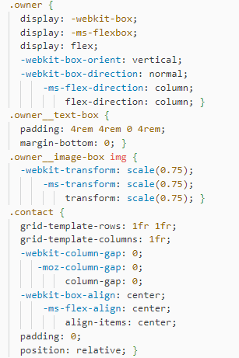

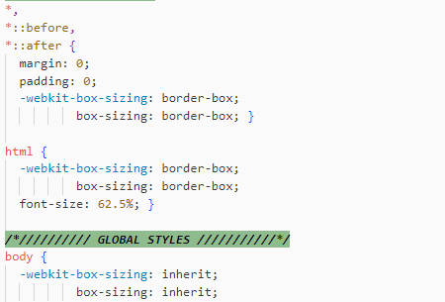

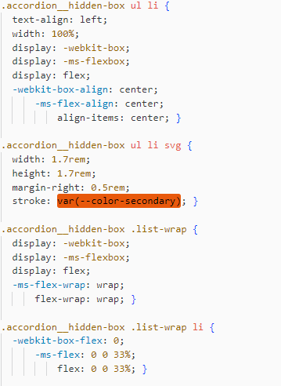

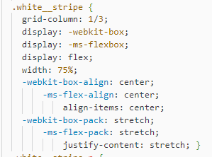

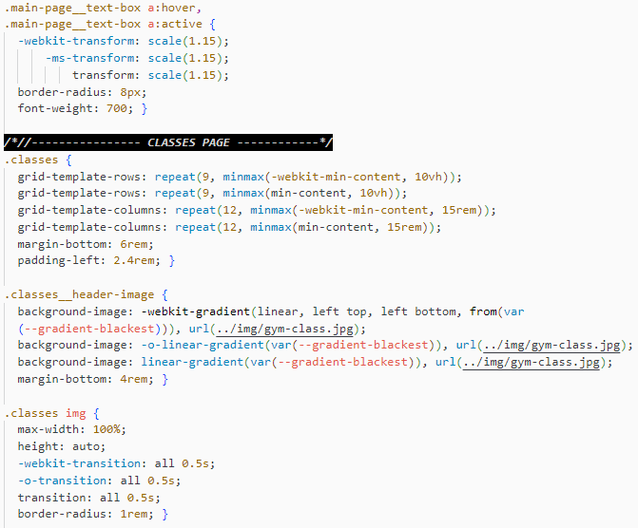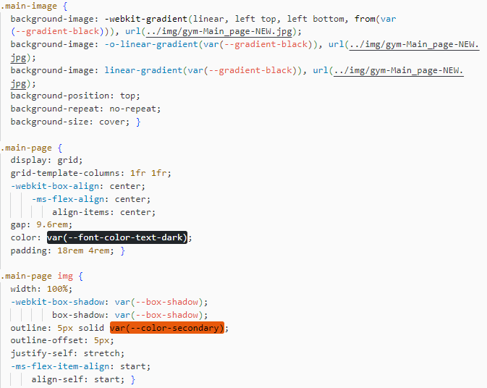

3.6 Accessibility Testing

Index.html Test-1 -FAILED

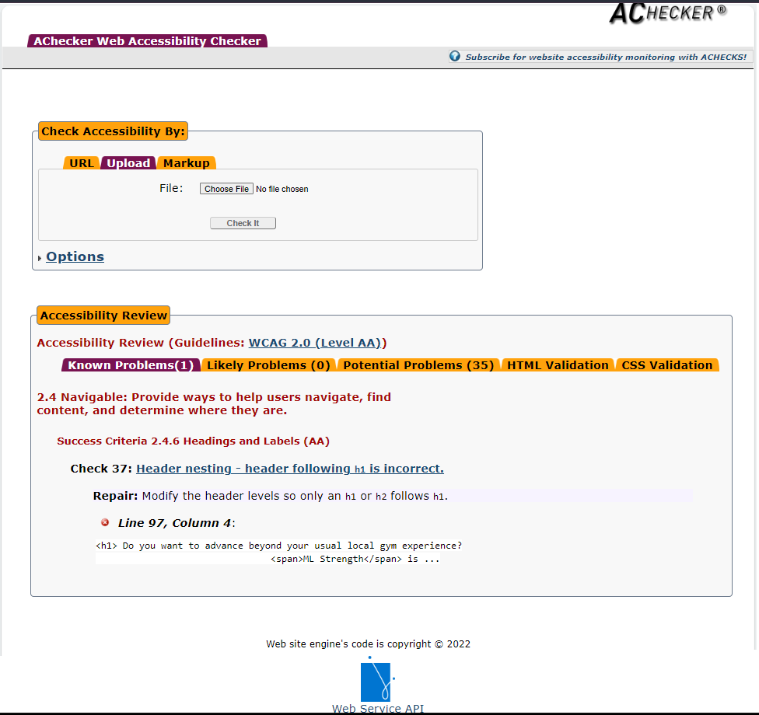

index.html Test-2 - PASSED

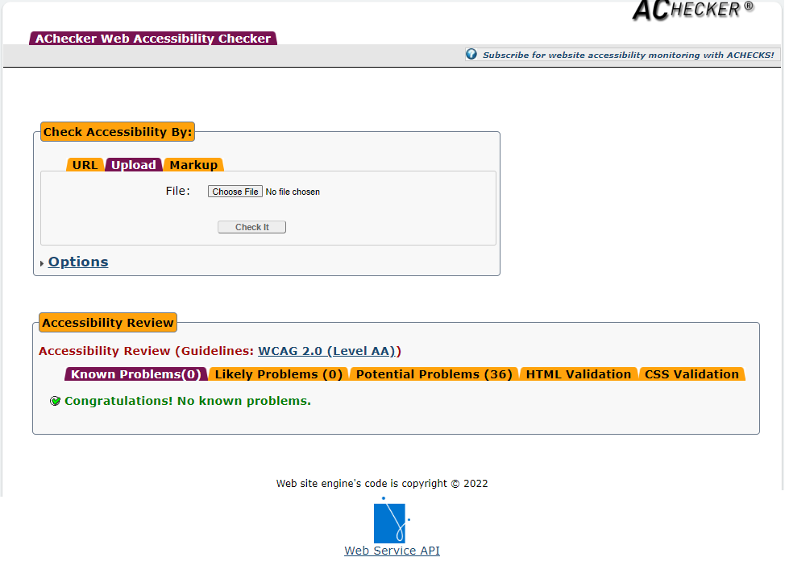

Classes.html Test -1 -FAILED

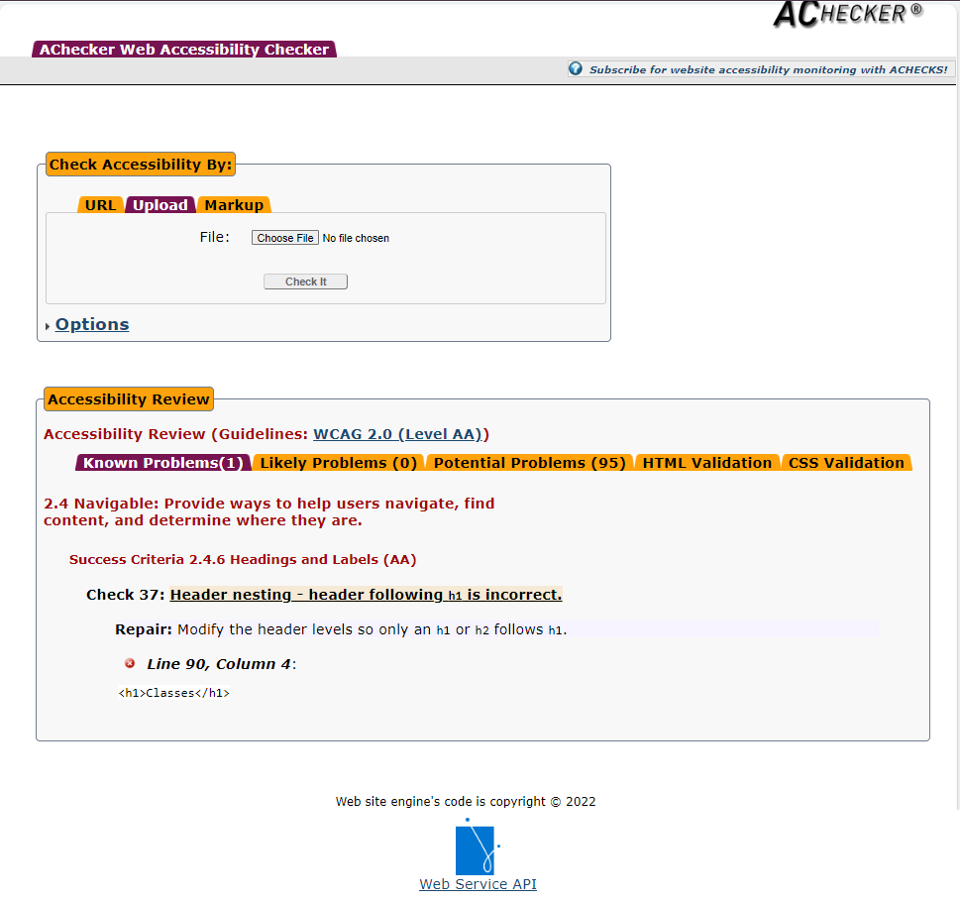

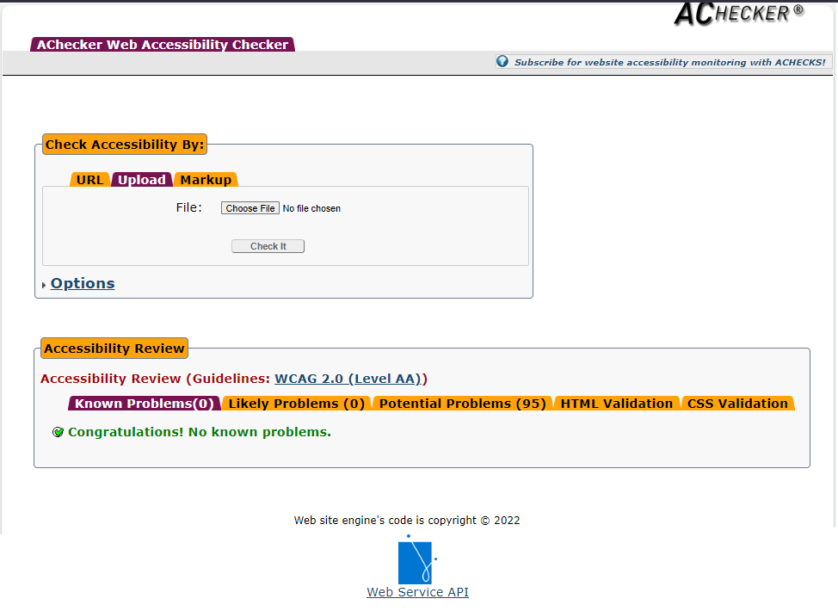classes.html Test -2 – PASSED

Philosophy.html – Test -1 – PASSED

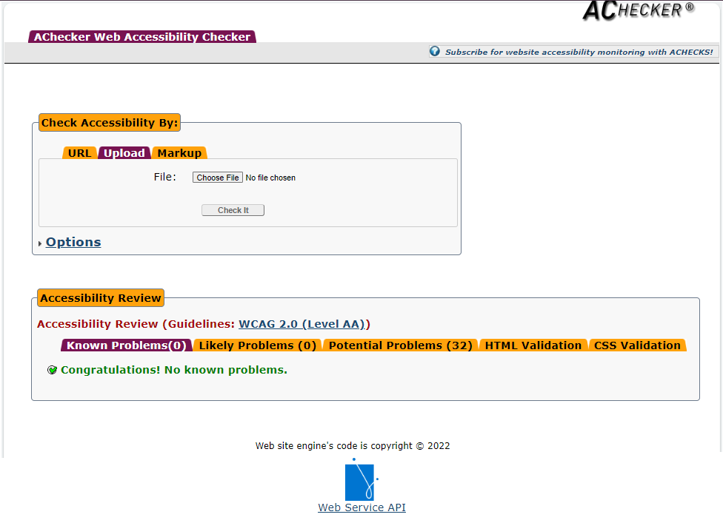

owner.html – Test -1 – PASSED

Contact.html – Test-1 – FAILED

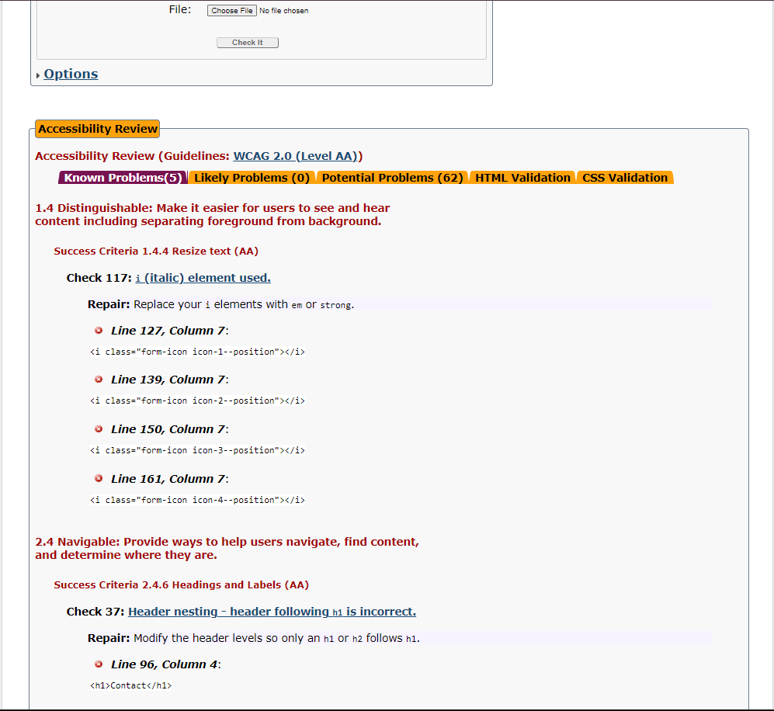

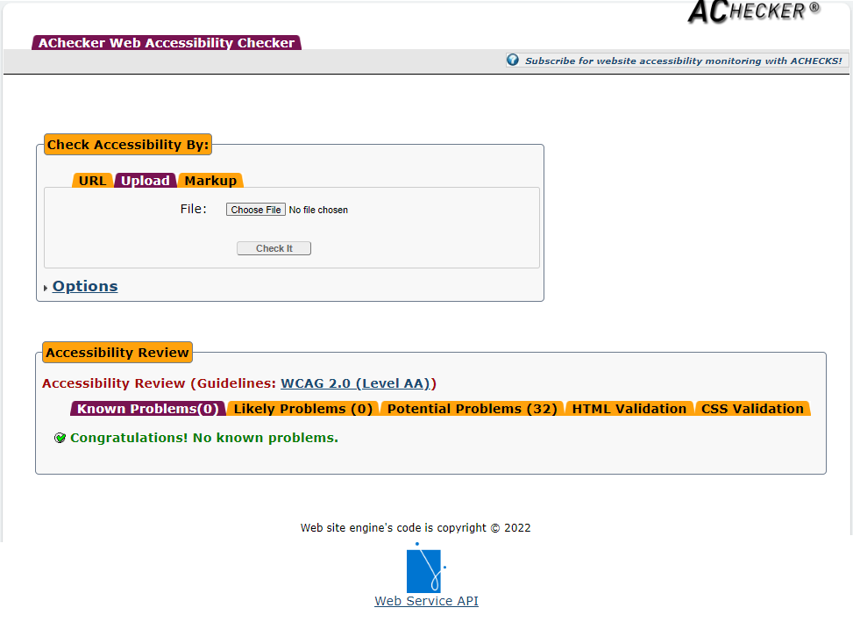

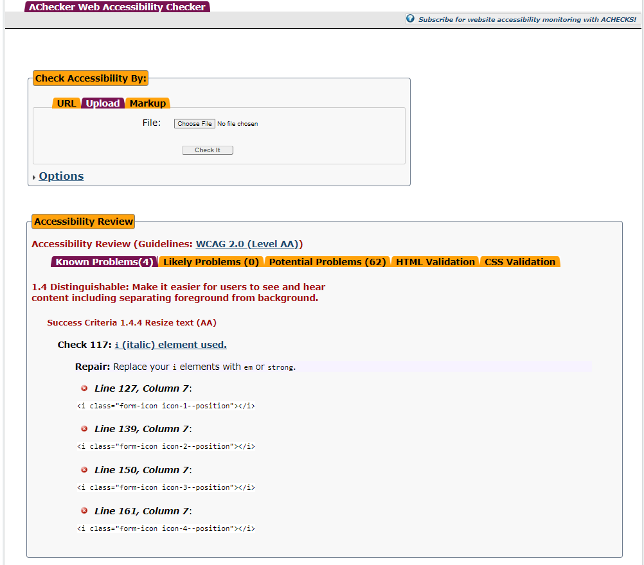Contact.html – Test-2 – FAILED

* Although <i> tag is no longer used for italic emphasis – when using font awesome icons, it needs to be used for the icon styling – so,therefore the <i> tag is not being used for italic emphasis, as the <em> tag would be used, and should pass accessibility testing.

3.7 Cyber security measures

*Include the answers to the cyber security questions here*

Authentication process

Programmatically engineered solutions to avoid cyber-attacks

Internet protocols

Project Signoff

*Copy, paste and complete the project signoff table from the assessment document*

Appendices

*Include any appendices in this section*

References

*Include any references in this section*